Learning Angular Notes by seeing Video Lectures on Training Portal

To write inline css and html use ` ` back ticks.

selector’s can be used in two ways

@Component({

selector: ‘app-servers’, element selector

template:

selector:‘[app-servers]’, This is attribute selector , you can select by attribute.

<div app-servers></div>

selector:’.app-servers’

<div class=”app-servers”></div>

<button [disabled]=”!allow”>

And boolean variable allow can be managed in component.ts file.

SetTimeout(()=>{

this.allow=true;

},2000)

Ts to Html

{{data}}

[propertyName]=”data”

Html to Ts (React to User events)

(event)=”expression”

(input)=”methodName($parameter);

methodName(parameter:any){

console.log(parameter);

this.enteredText=(<HtmlInputElement>event.target).value;

//This is explicit casting of event’s targetted element into HtmlInputElement type

}

Two Way

[(ngModel)]=”data”

Class Binding

public myStyle:string=’red-class’;

public myColor=”blue”;

<div [class]=”myStyle”>

<div [style.color]=”myColor”>

Directives :::

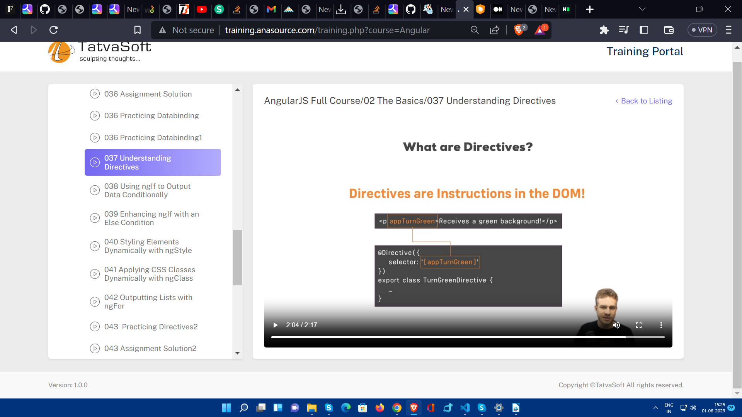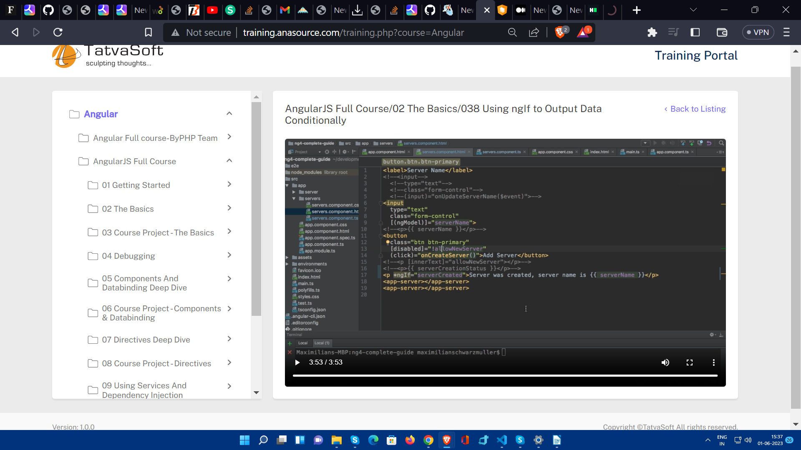

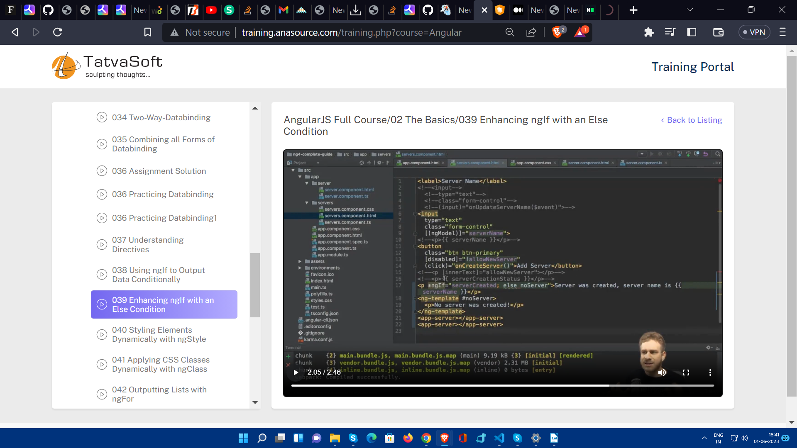

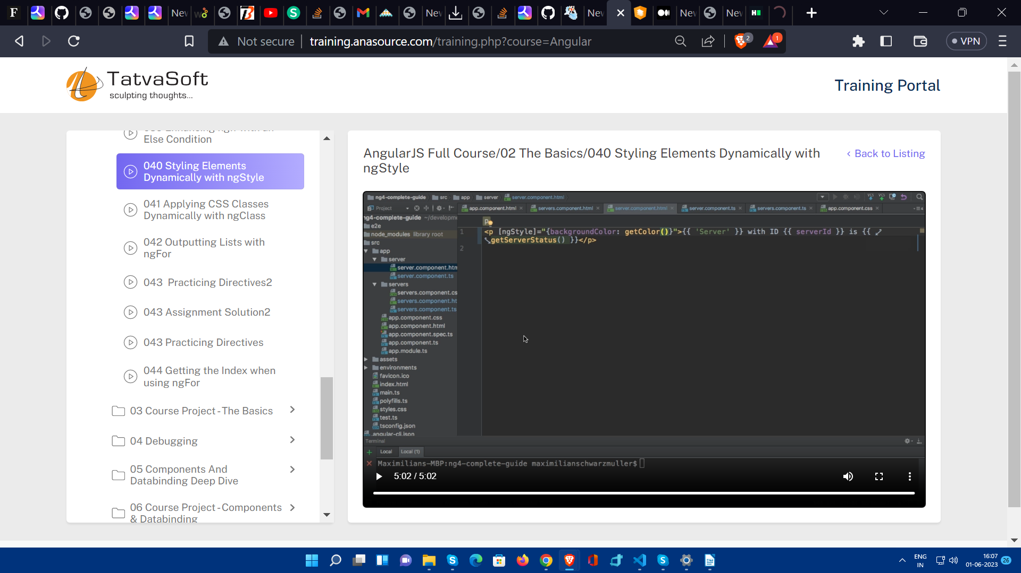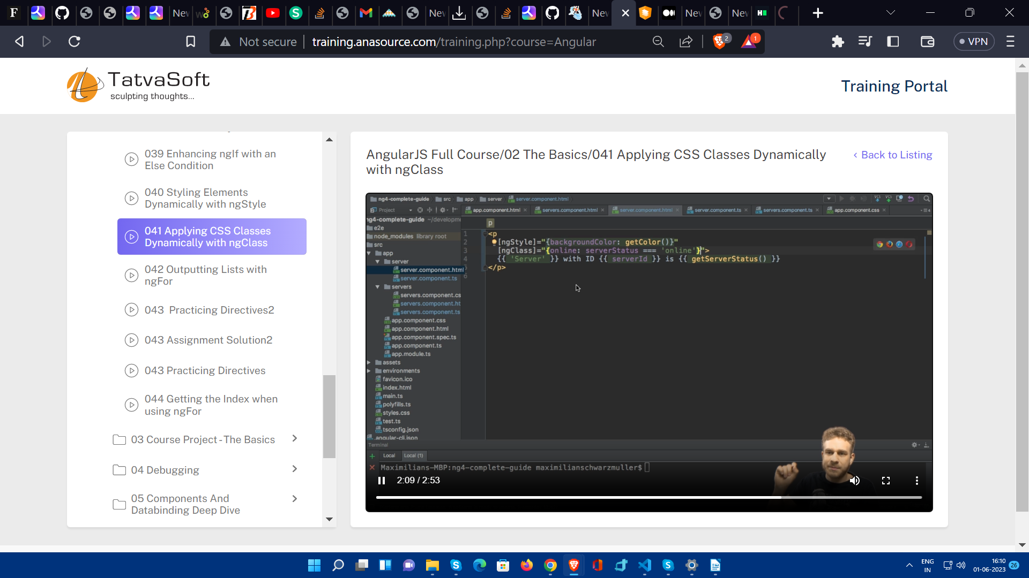

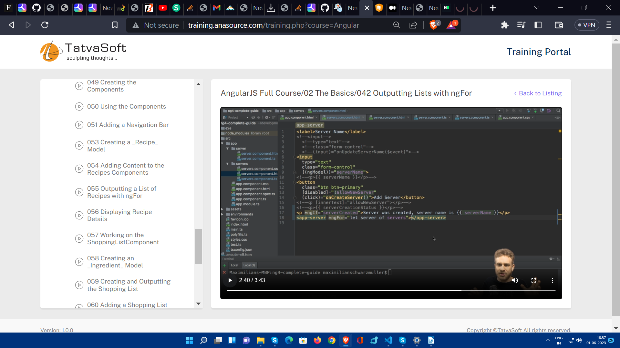

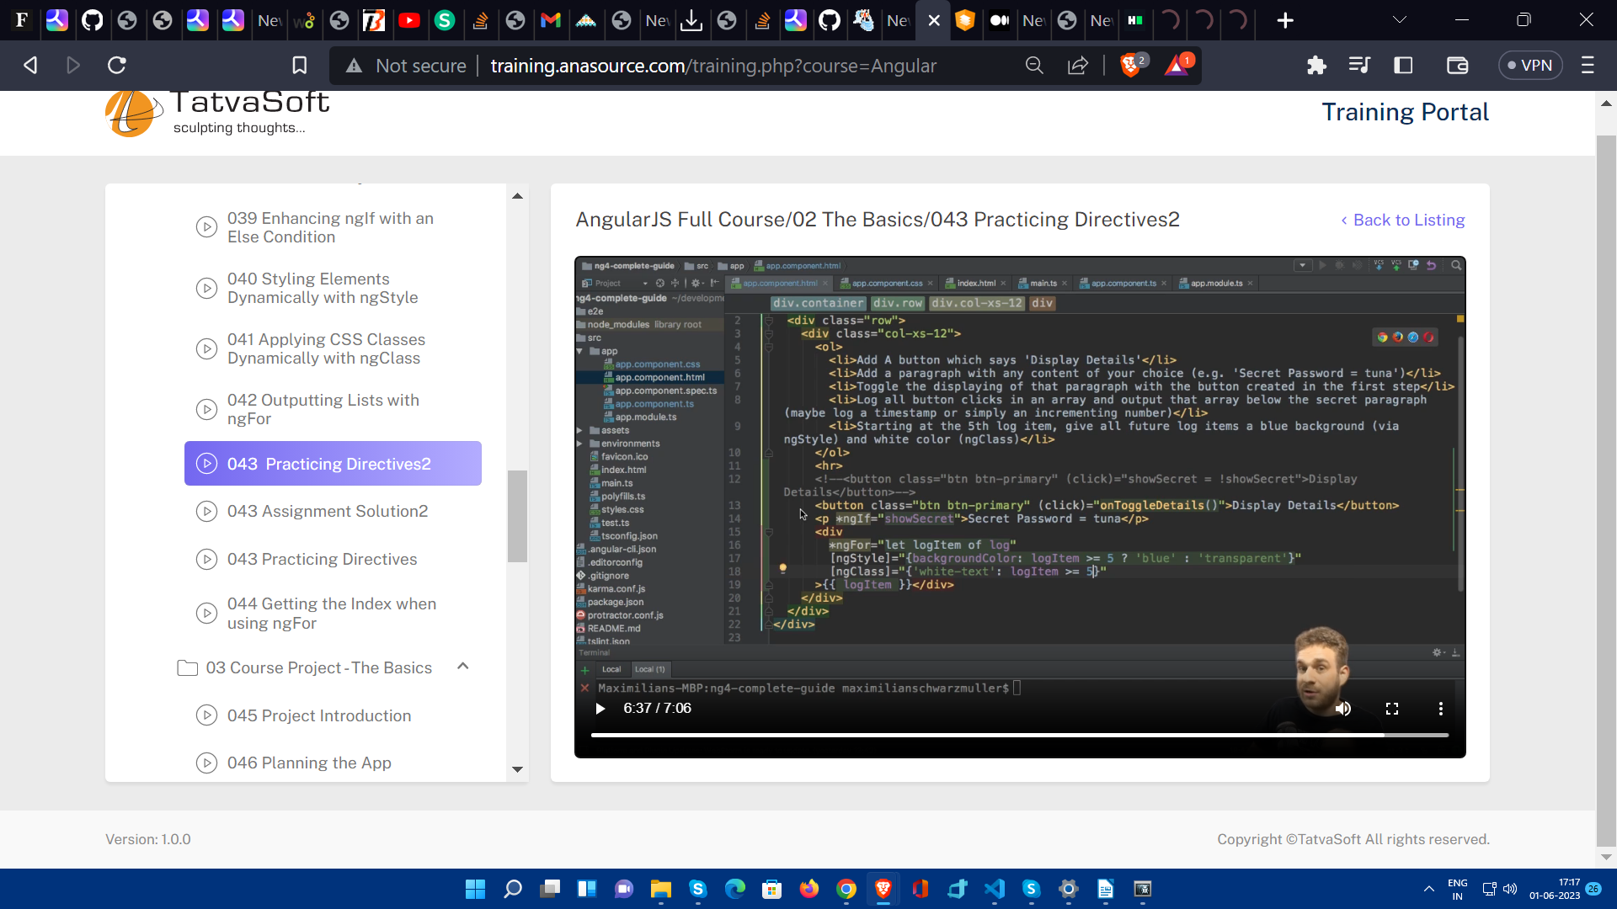

**Data Communication between components**

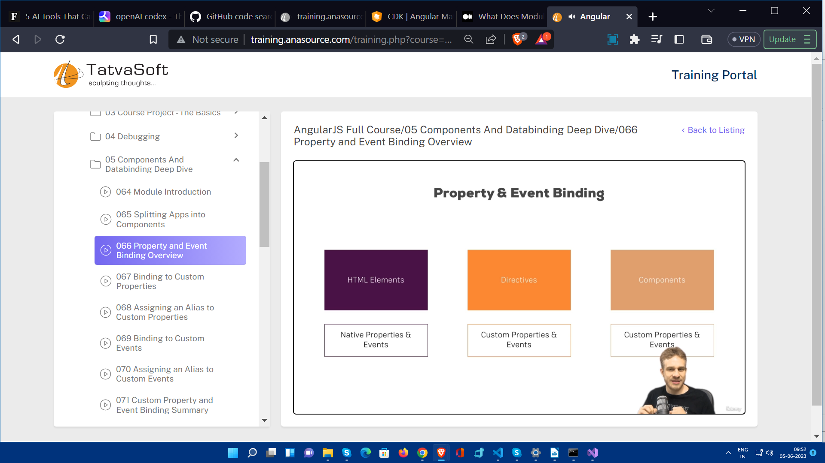

**Properties in the component can be only used with in the component.** To use property off child component into its parent component you just to use input decorator and expose that property. Here we have used element property of server-element component in app component , we have to use @Input() directive for exposing this property.

Because here from app component we want to pass current iteration of serverElements array (which is serverElement) to the element property (which is app-server-element component’s property) and we will use this element property into that component to display values.

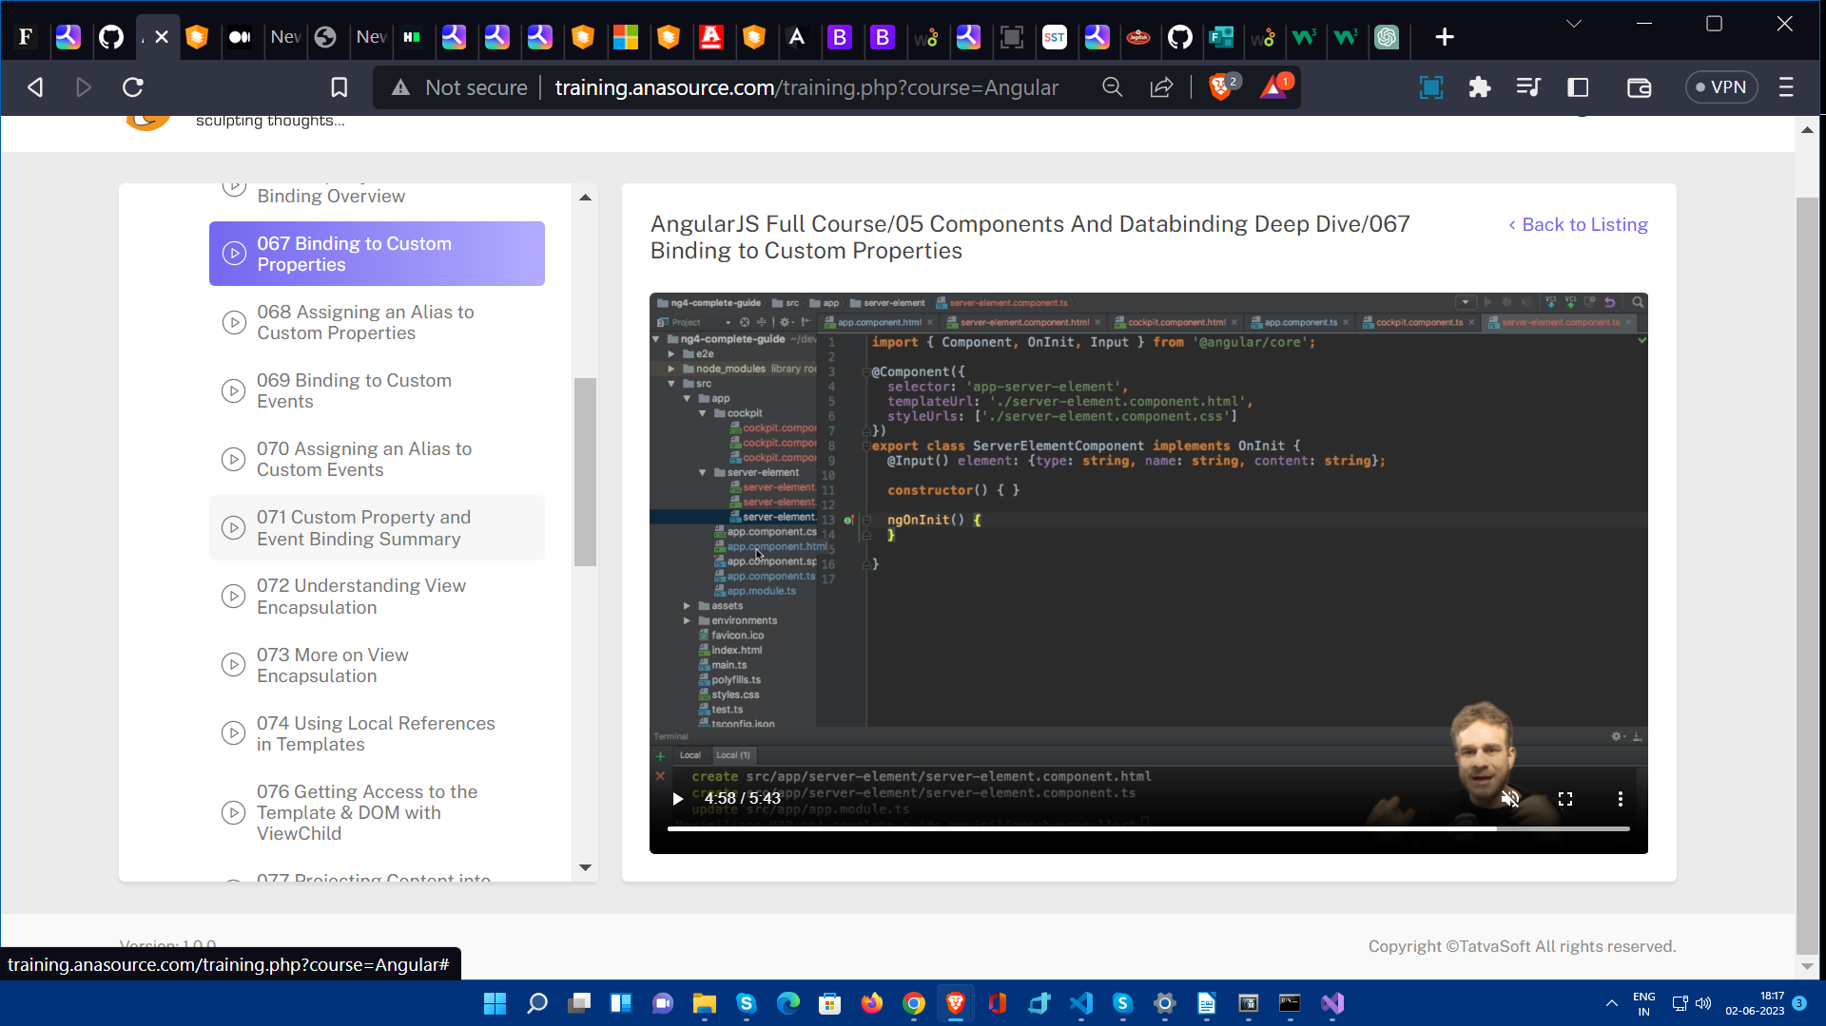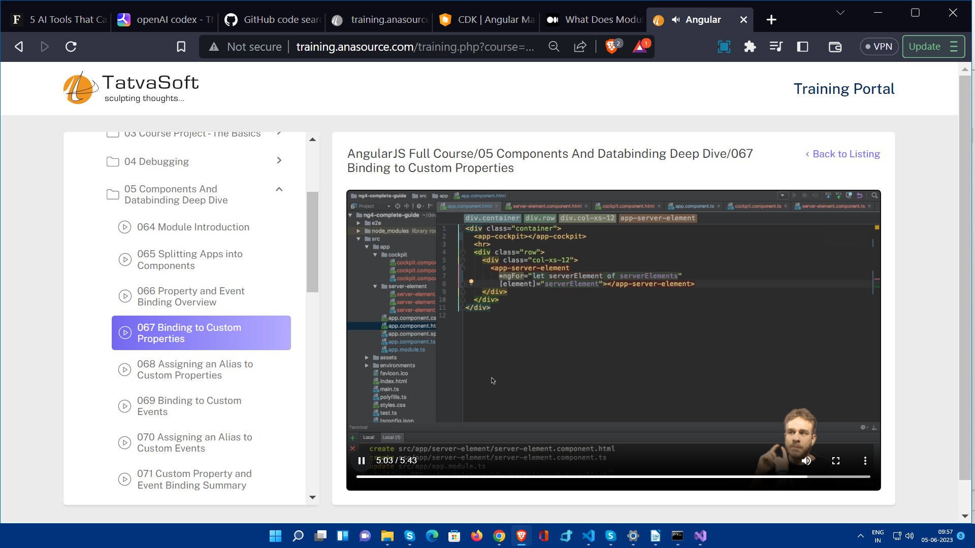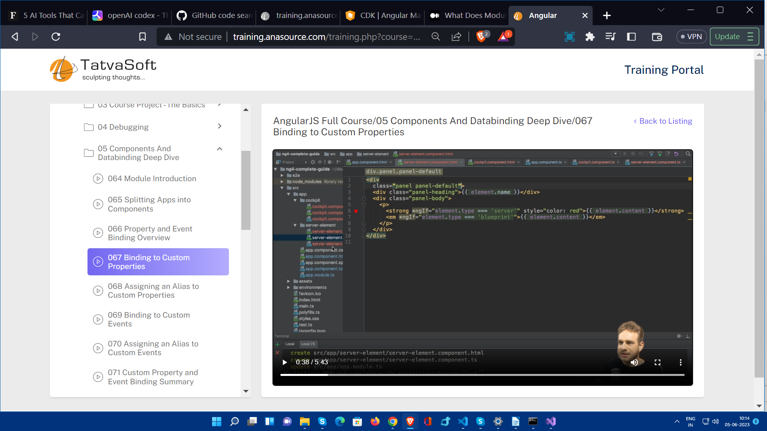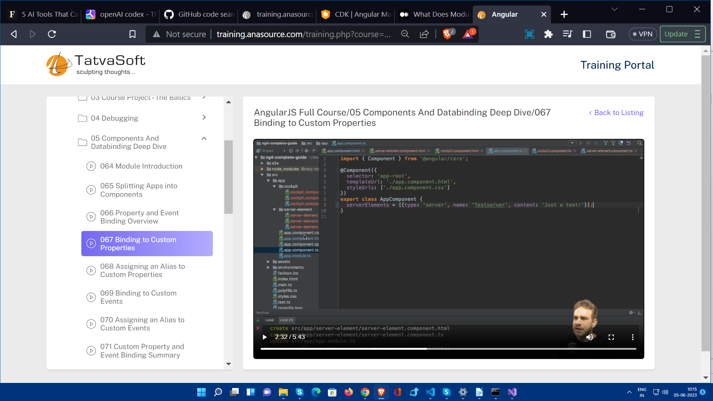

We cam also use alias. In the above scenario if i want to access element property with a different name than its orignal one then alias assignment can be done.

**@Input(‘srvElement’)**

Now all other component have to access this with this srvElement name instead of orignal name.

Here is how we can modify child component by passing data from parent component.Because here app component passed data to its child component’s property.That’s why we used [srvElement]=” ...” in app.compo.html because we are sending info from here to server-element.compo.html.So this is custom property binding.

Now . If we want completely opposite case of this when , we want to passs info from child to its parent compo if any event occurs.

So we have a child compo named cockpit. Like this

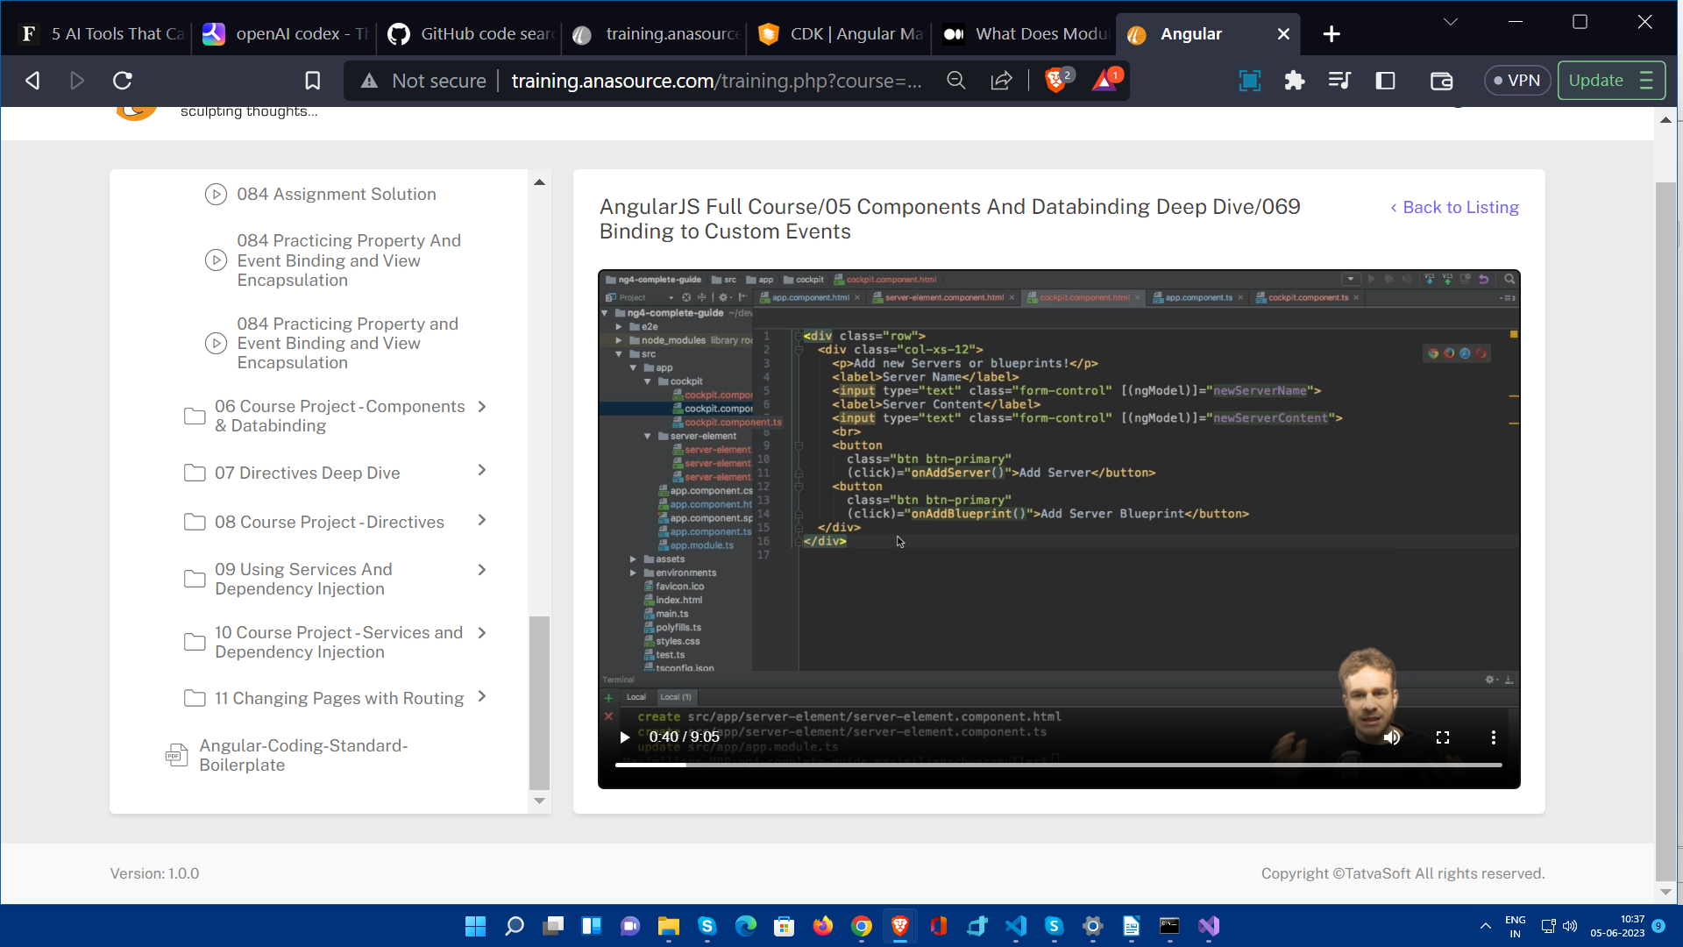

Here newServeName and newServerContent both properties are two way binded using ngModel.

And on buttons there are click events which execute methods.

Now Here is cockpit.compo.ts

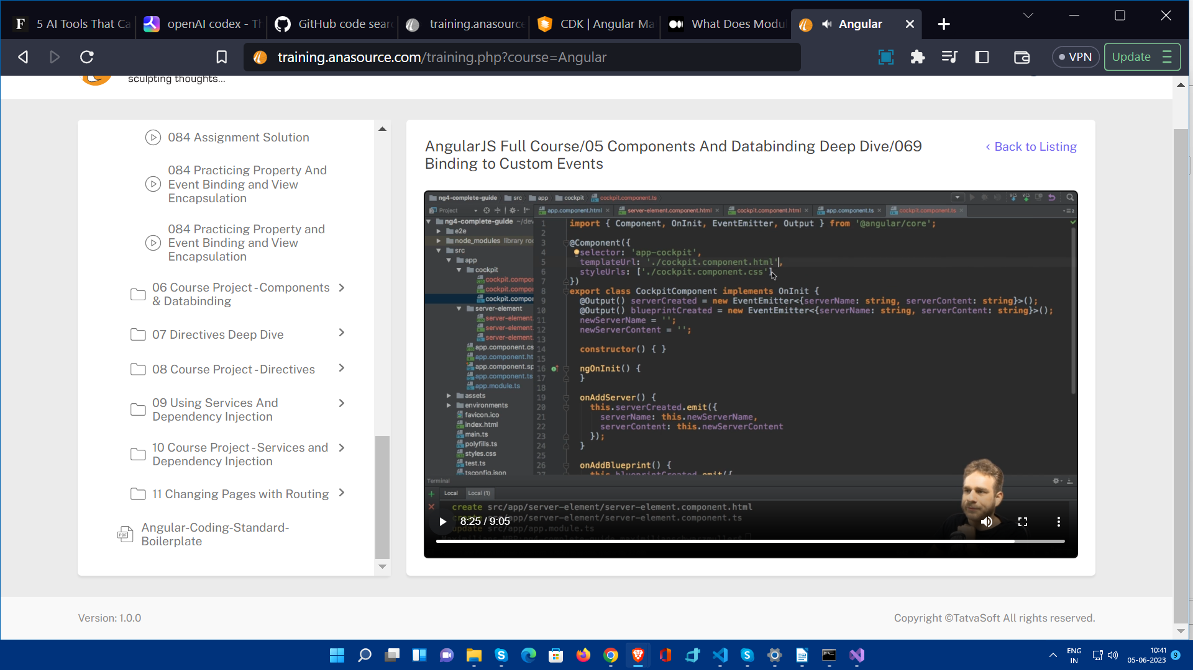

Here newServerName and newServerContent properties are declared becuase ultimately the eneterd data will passed into that.

Now , when Add Server is clicked and onAddServer got executes we need to pass name and content two key , value pairs to parent app.component.

For that first we declared property serverCreated and as here this property is for sending data outside (in previous case we were getting data via @Input() element:{...};) , so @Output() is used.

EventEmitter is a generic type and we have to configure type of data that will be getting passed betweeen < > and then we have created constructor of this class and initialized one object by doing () and that object is stored in serverCreated property.

Then in OnAddServer we have used this object’s property (or method) .emit() and binded name , content value to this object’s properties.

Now as we by using this serverCreated property in parent component , we will be able to display name and content .

Here how we are going use this values

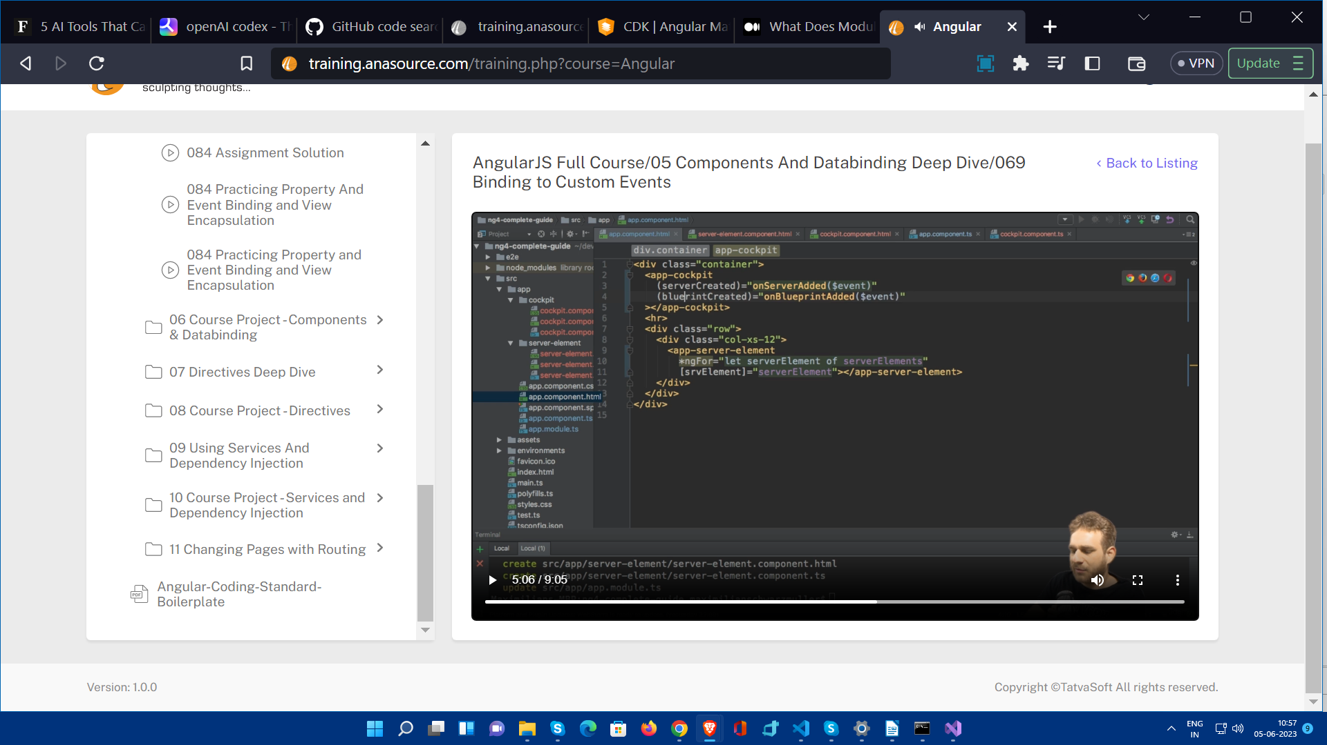

In app.component.html file we have used cockpit component just like server-element.

So , we are listening to this serverCreated property , which will emit name and content.

The method onAddServer() will get executed and when user will click on “Add Server” button which is in cockpit. So when onAddServer() method will get execute, the serverCreated will emit these values.

And whenever serverCreated will emit something the onServerAdded($event) method will be called and event will passed to this method.

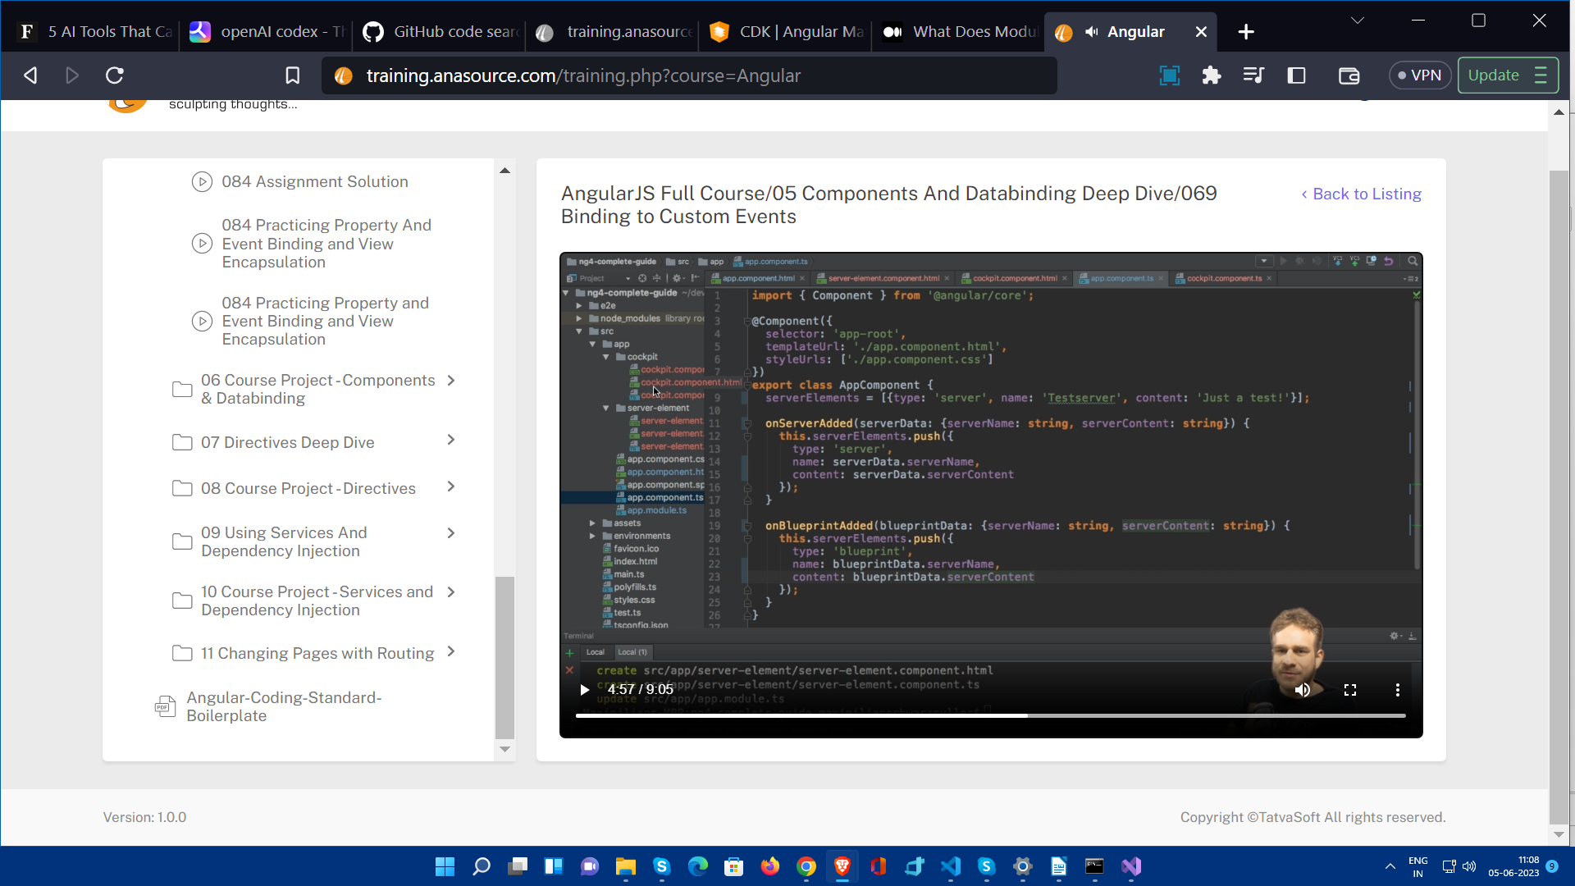

So , here onServerAdded method will accept data in declared formate and that data will be assigned in serverData variable and then we will push this instace of server in serverElements array.

We can also use alias in Output same as Input

@Output(‘bpCreated’)

**So , in this way here we have get data from cockpit component on the click on Add Server button into app component and pushed in the array which we are using in app component and we have also sent each srvElements to app-server-element and ultimately that server-element component is displaying received data from app component.**

If we don’t want to do Two way binding in cockpit component , we can use local references (only in template file) , this local reference will send whole html element.

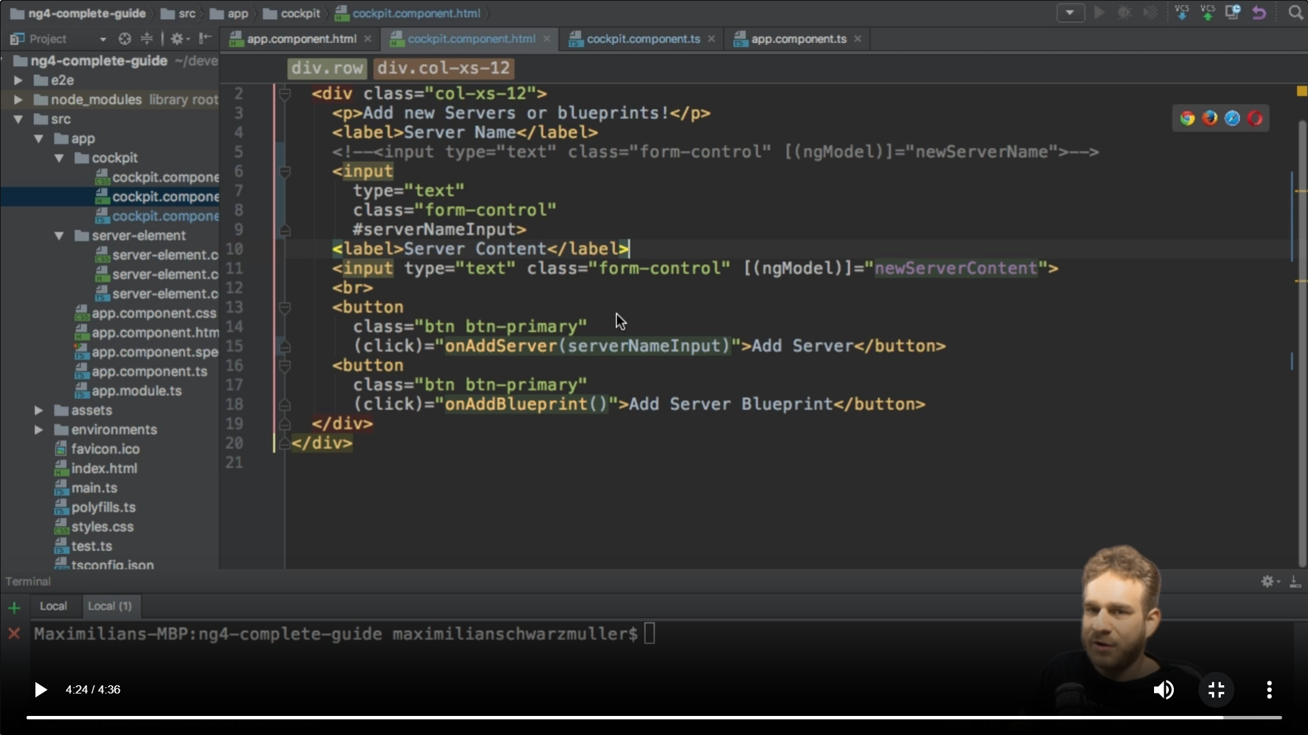

Here whole input element is passed via #serverNameInput to the onAddServer() method.

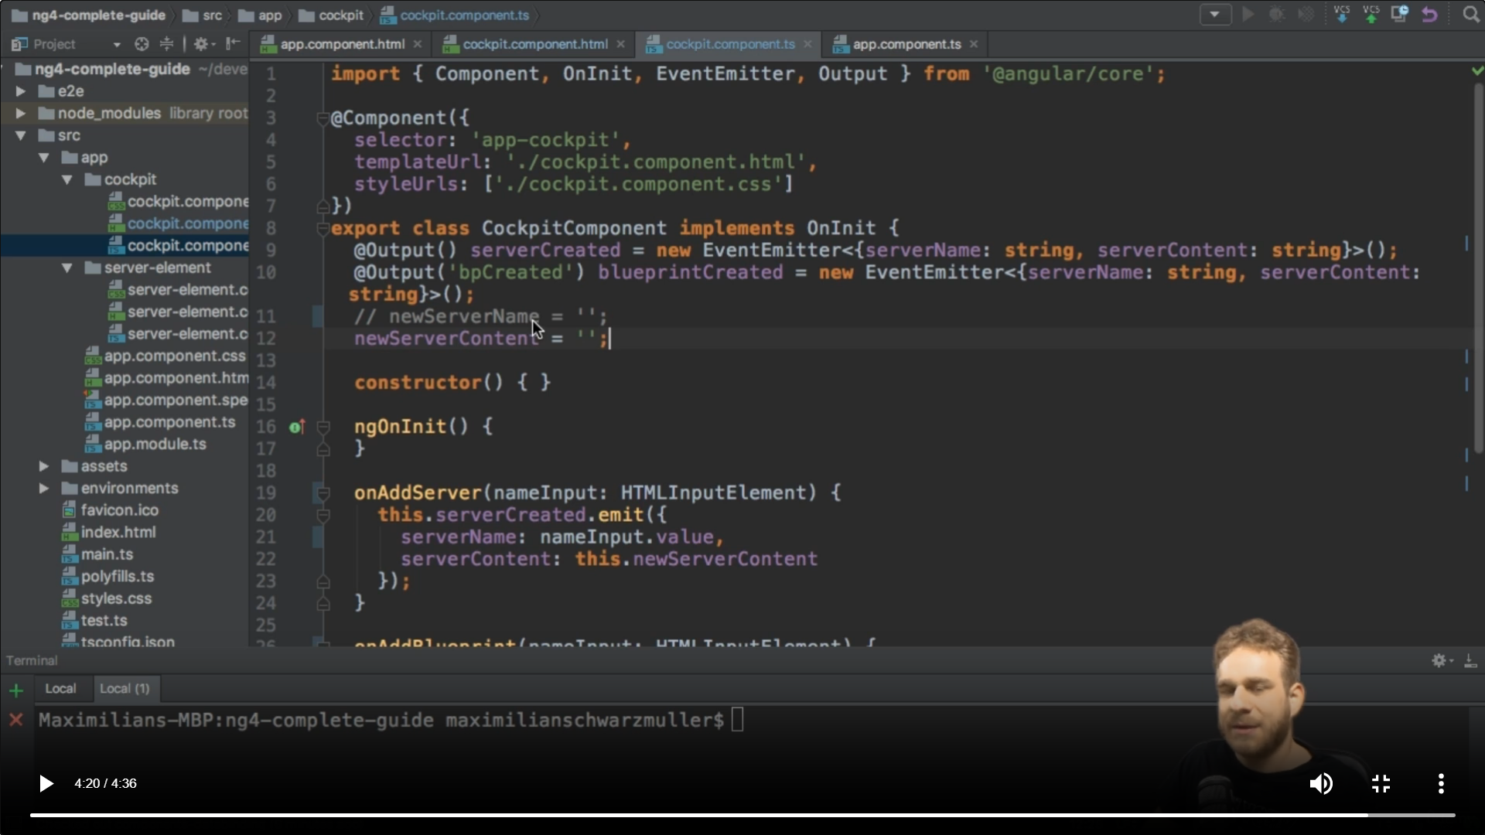

And here it is taking parameter of type HTMLInputElement and its value can be used anywhere like this.

Angular enforces encapsulation on behaviour of css styling rules. CSS styling rules can only be applied with in that particular component.

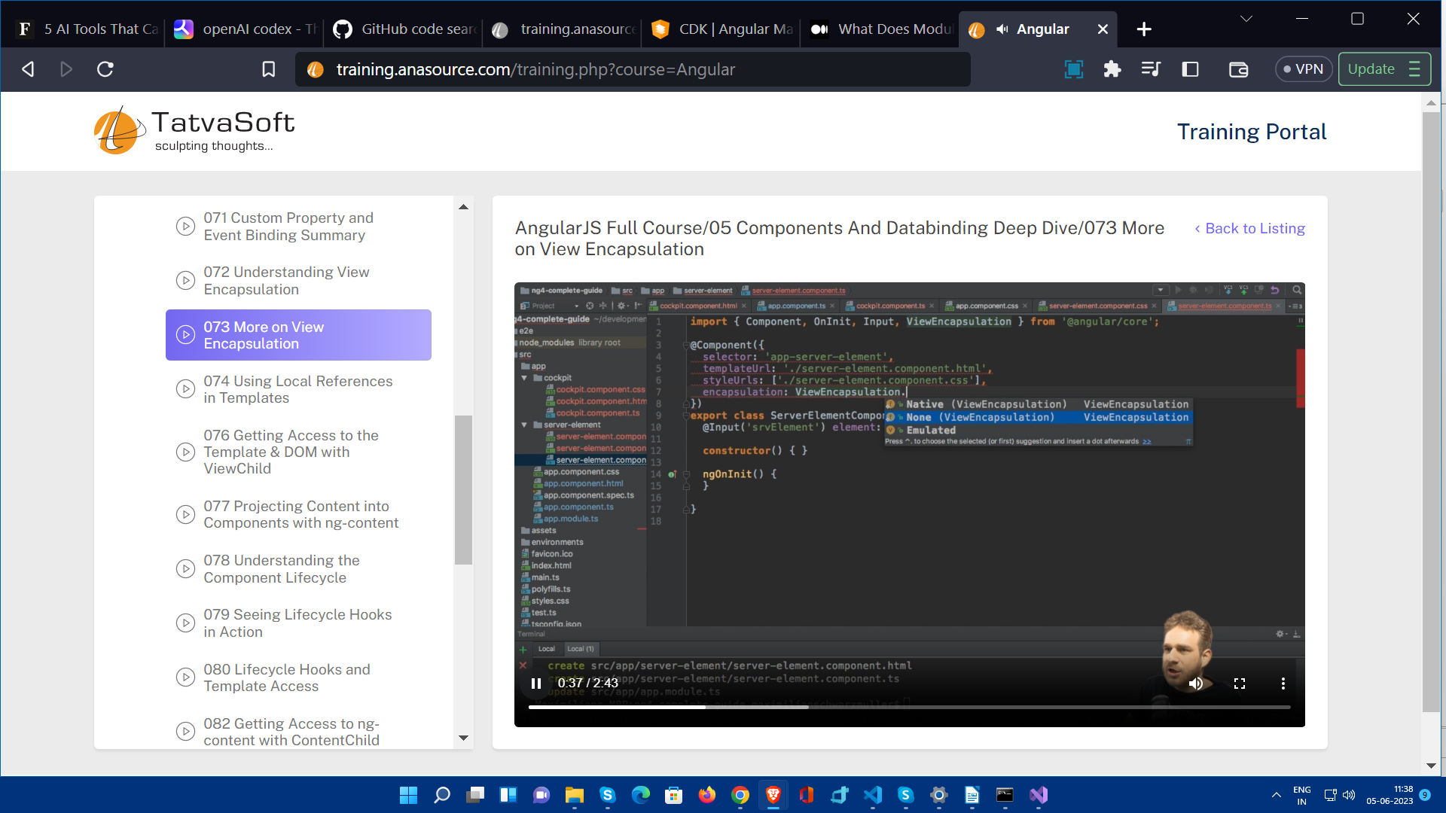

Here Emulated is default type.

Use cases:

* Use ViewEncapsulation.None when you want to define global styles that should apply across the entire application.
* Use ViewEncapsulation.Native when you specifically want to leverage the native Shadow DOM feature and have better encapsulation, if the target browsers support it.
* Use ViewEncapsulation.Emulated as the default option for encapsulating styles within a component, providing good encapsulation and broader browser compatibility.

In the case of View Encapsulation.Native, Angular leverages the native Shadow DOM support to encapsulate the styles of a component within its own Shadow DOM. This means that the styles defined in the component will be isolated and will not affect other components or elements outside of its scope. By leveraging the native Shadow DOM, Angular can provide better encapsulation and style isolation within the component's view.

**But only if browser supports it.**

ViewEncapsulation.Native: With ViewEncapsulation.Native, Angular utilizes the native Shadow DOM support provided by the browser. The styles defined in the component are encapsulated within the component's Shadow DOM, ensuring that they don't leak out and affect other components. This means that the styles are scoped and isolated to the specific component, providing true encapsulation. However, it's important to note that not all browsers support Shadow DOM natively.

ViewEncapsulation.Emulated: ViewEncapsulation.Emulated is the default encapsulation mode in Angular. Instead of relying on native Shadow DOM support, Angular emulates the Shadow DOM behavior by adding a unique attribute to the component's HTML elements. These unique attributes are automatically generated and dynamically updated by Angular to avoid clashes between different components. The styles defined in the component are scoped to the elements with the added attribute, providing encapsulation similar to the native Shadow DOM. ViewEncapsulation.Emulated ensures broader browser compatibility as it doesn't rely on specific browser features.

The necessity of ViewEncapsulation.Native arises in scenarios where you want to take full advantage of the native Shadow DOM capabilities provided by the browser. Native encapsulation provides stronger isolation and encapsulation compared to the emulated approach. It ensures that the styles defined in a component are truly encapsulated within its Shadow DOM and do not leak out to affect other components or elements in the application.

However, it's important to consider browser compatibility when using ViewEncapsulation.Native, as not all browsers support Shadow DOM natively. If broader browser support is a requirement, or if the styling needs are relatively simple, ViewEncapsulation.Emulated is a reliable and widely compatible choice for encapsulating component styles.

Reference : - <https://chat.openai.com/share/7348a69f-90a2-46e5-9922-2bce37eef2f1>

<ng-content></ng-content>

It is a hook , if you have used in component then it will place html content enclosed by <app-server-element> tag in app.component (whenever component is used).

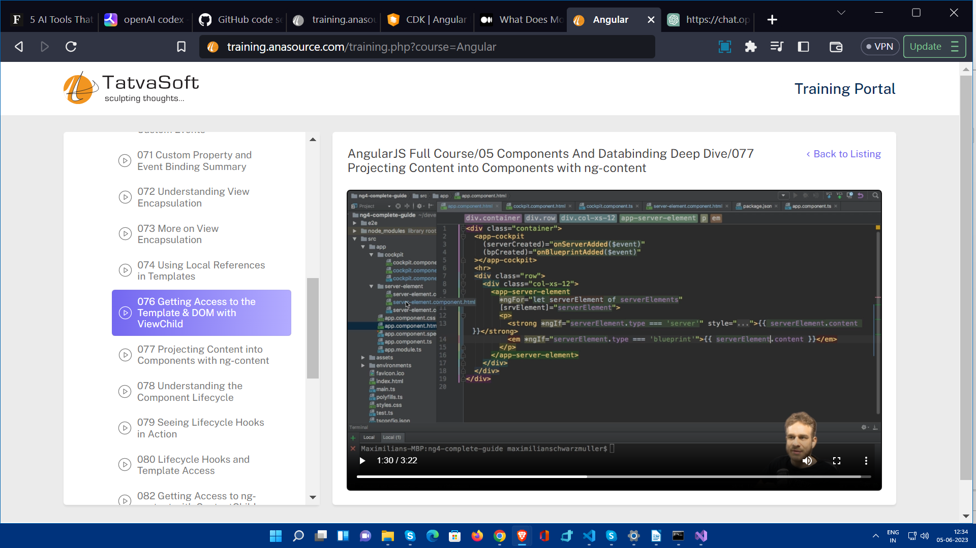

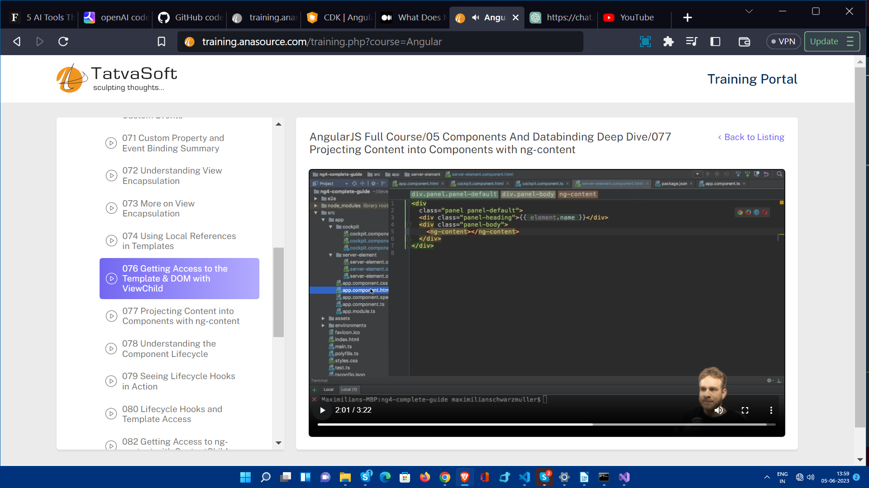

**Hooks**

A life cycle event or method provided by the Angular framework that allows you to perform specific actions at different stages of a component's life cycle. Hooks provide developers with the ability to react and respond to changes happening within a component, such as initialization, updates, and destruction.

Angular provides several hooks that you can use to execute code and perform tasks at various points in a component's life cycle. These hooks are predefined methods that you can override in your component class to add custom behaviour.

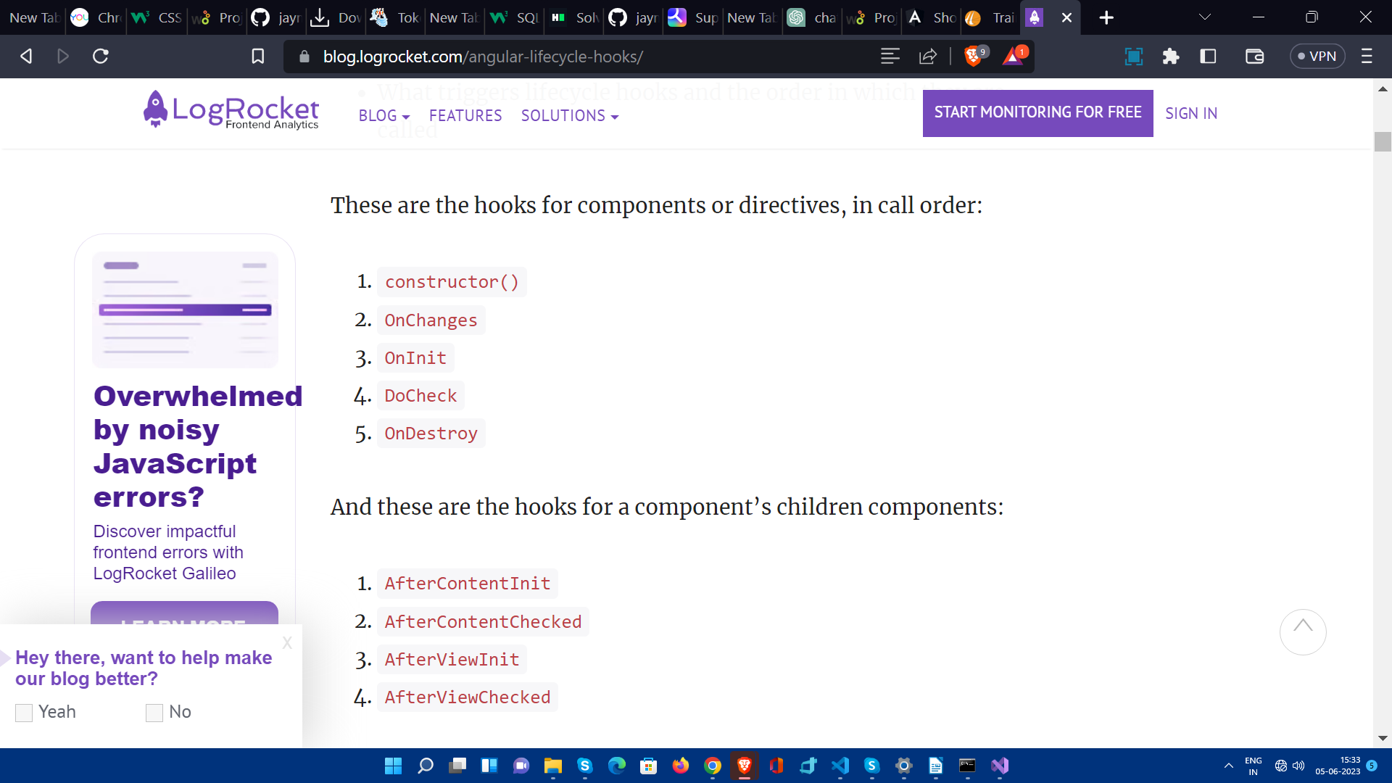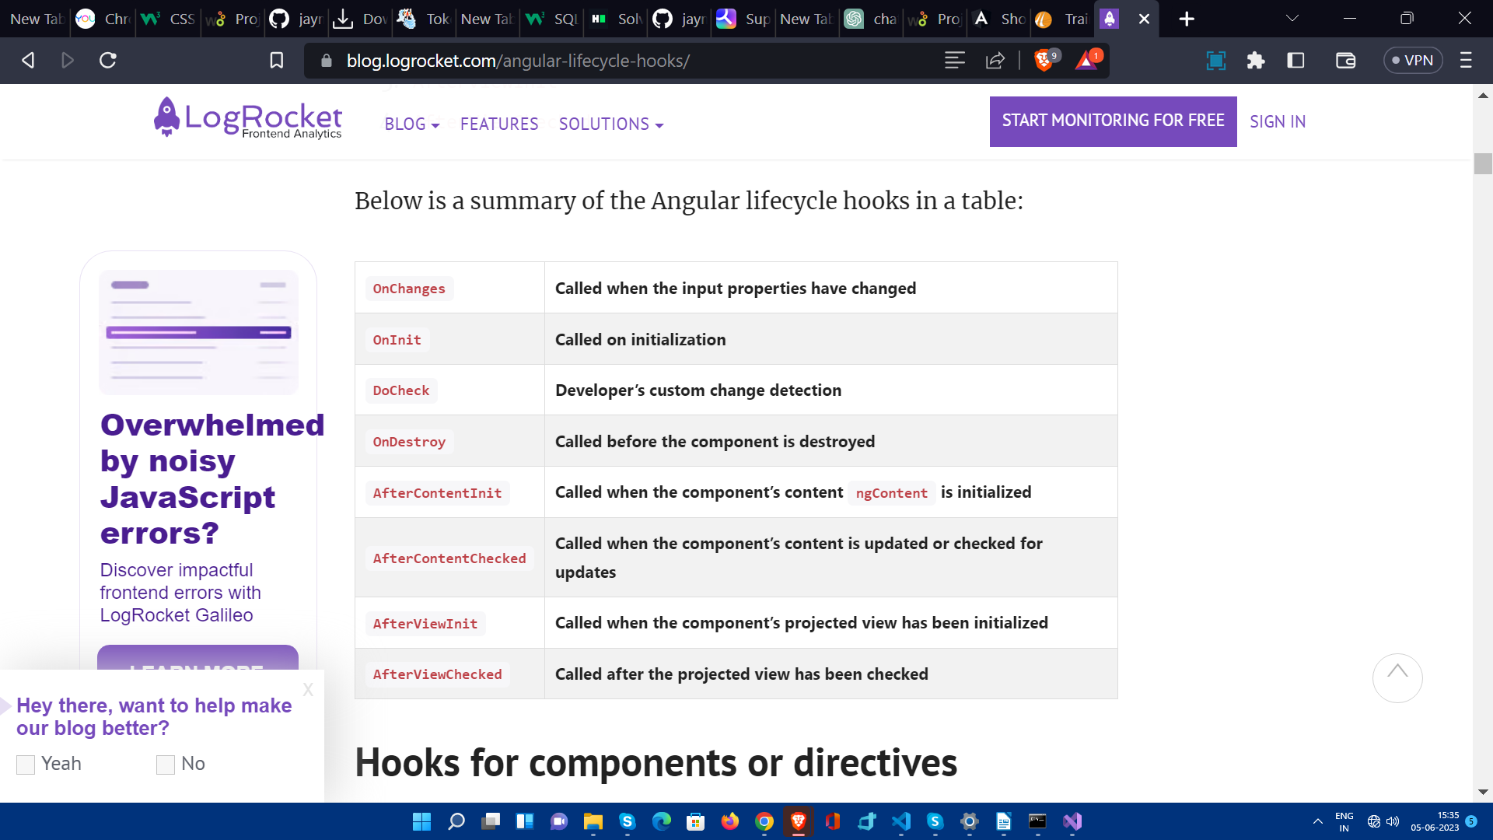

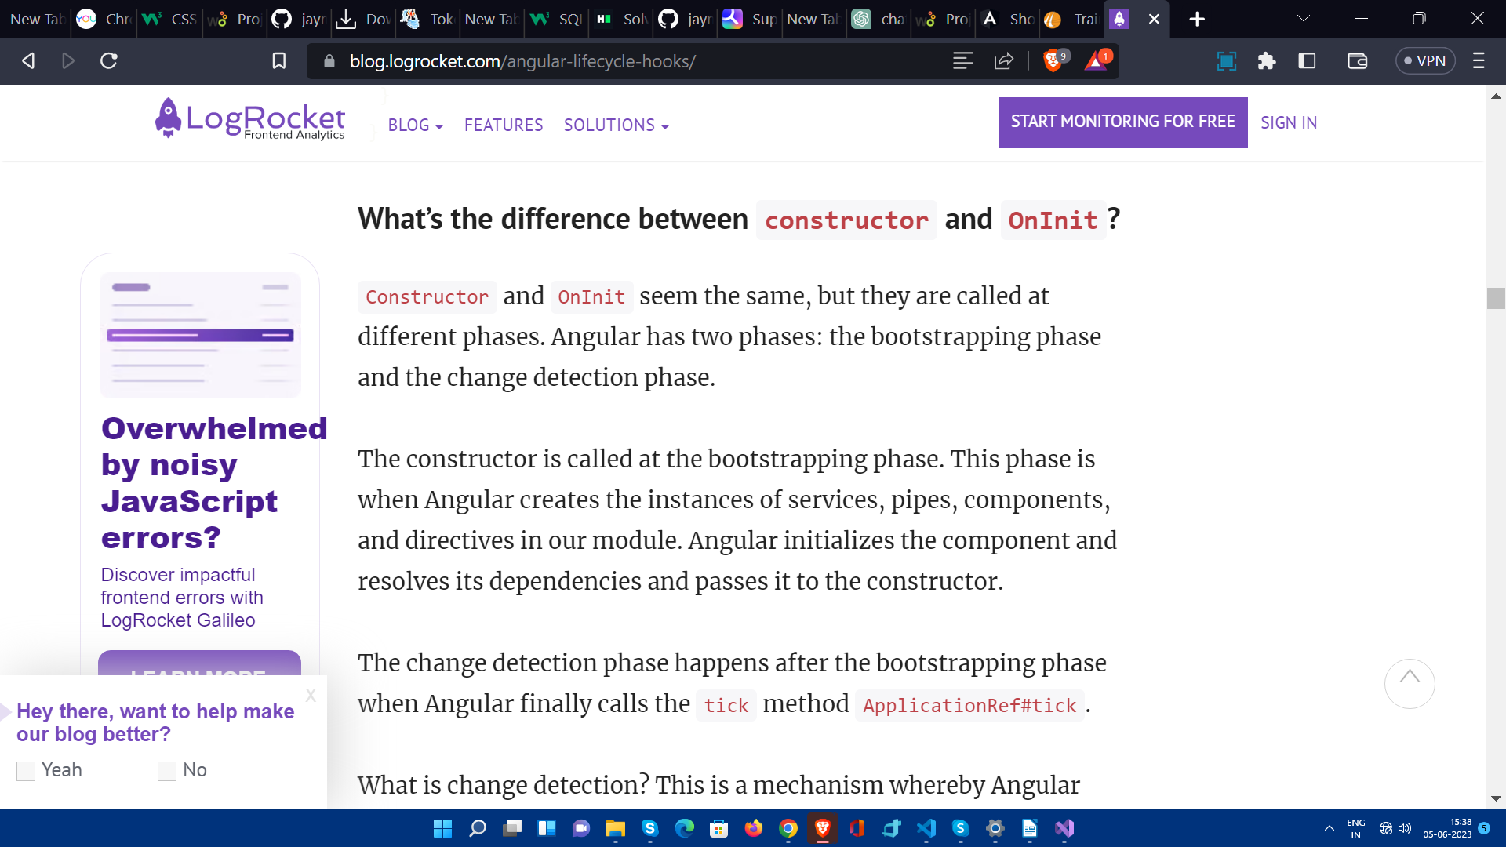

ViewChild : -

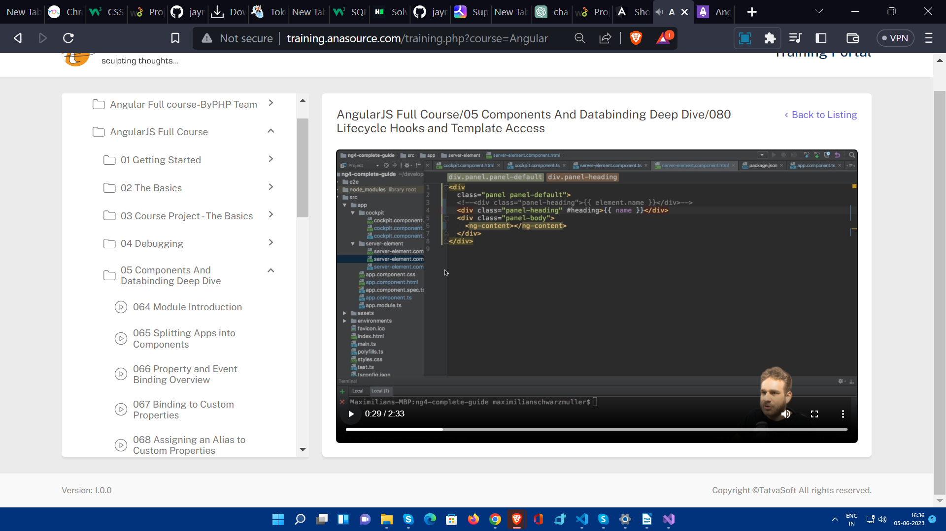

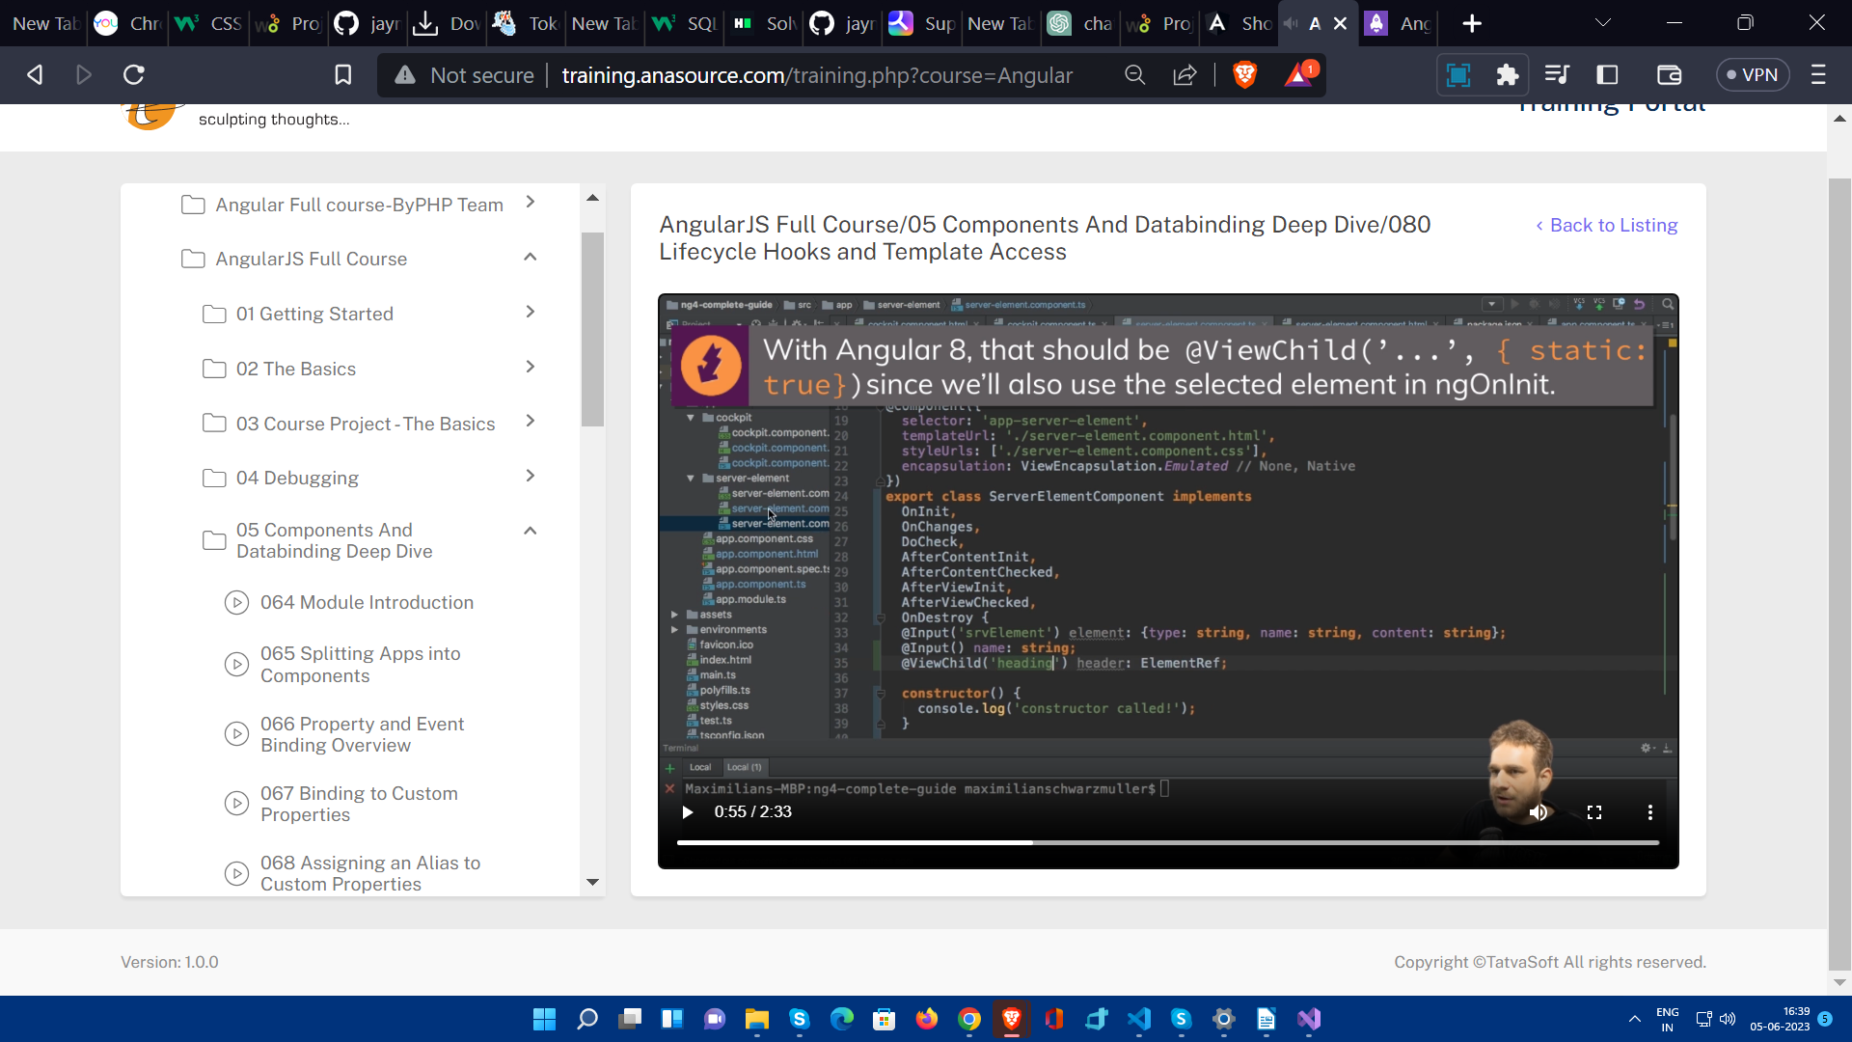

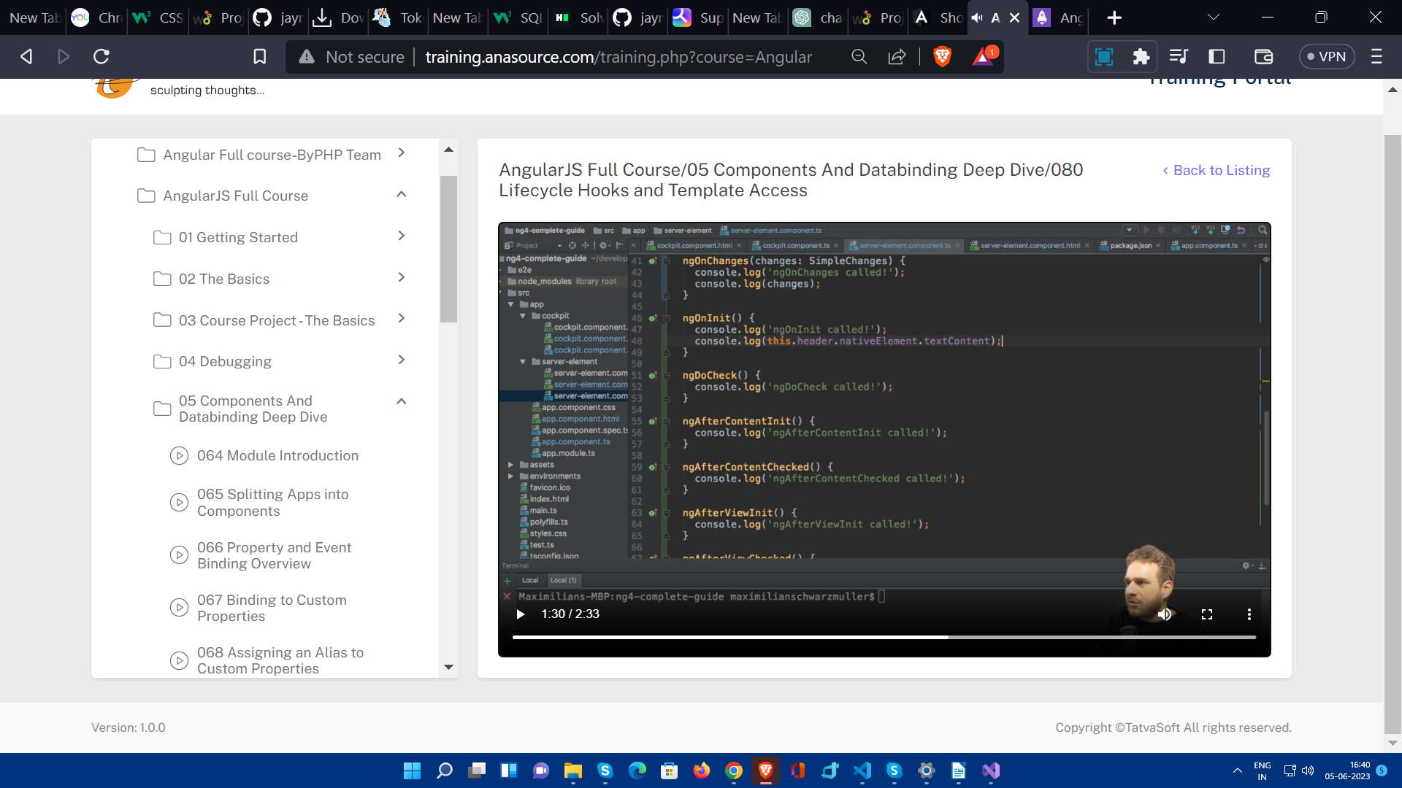

But you cannot use your @ViewChild property before ngAfterViewInit() gets called.

Here you want to access element with - in component's template then ViewChild is being used .But suppose reference is given to the html element which is in another component and that content is being passed to this component using ng-content then this would be across component reference, for handling that use

@ContentChild same as like ViewChild .

The difference is this properly will only be accessible after the ngAfterContentInit() gets called.

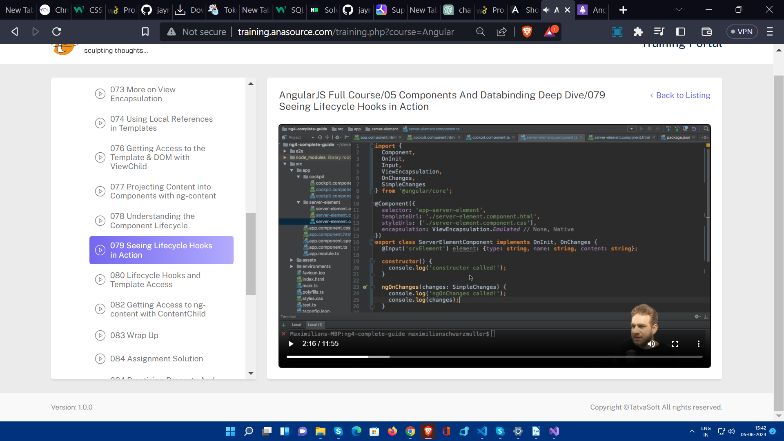

NgOnChanges is the only hook which receives an argument and it is of type SimpleChanges.

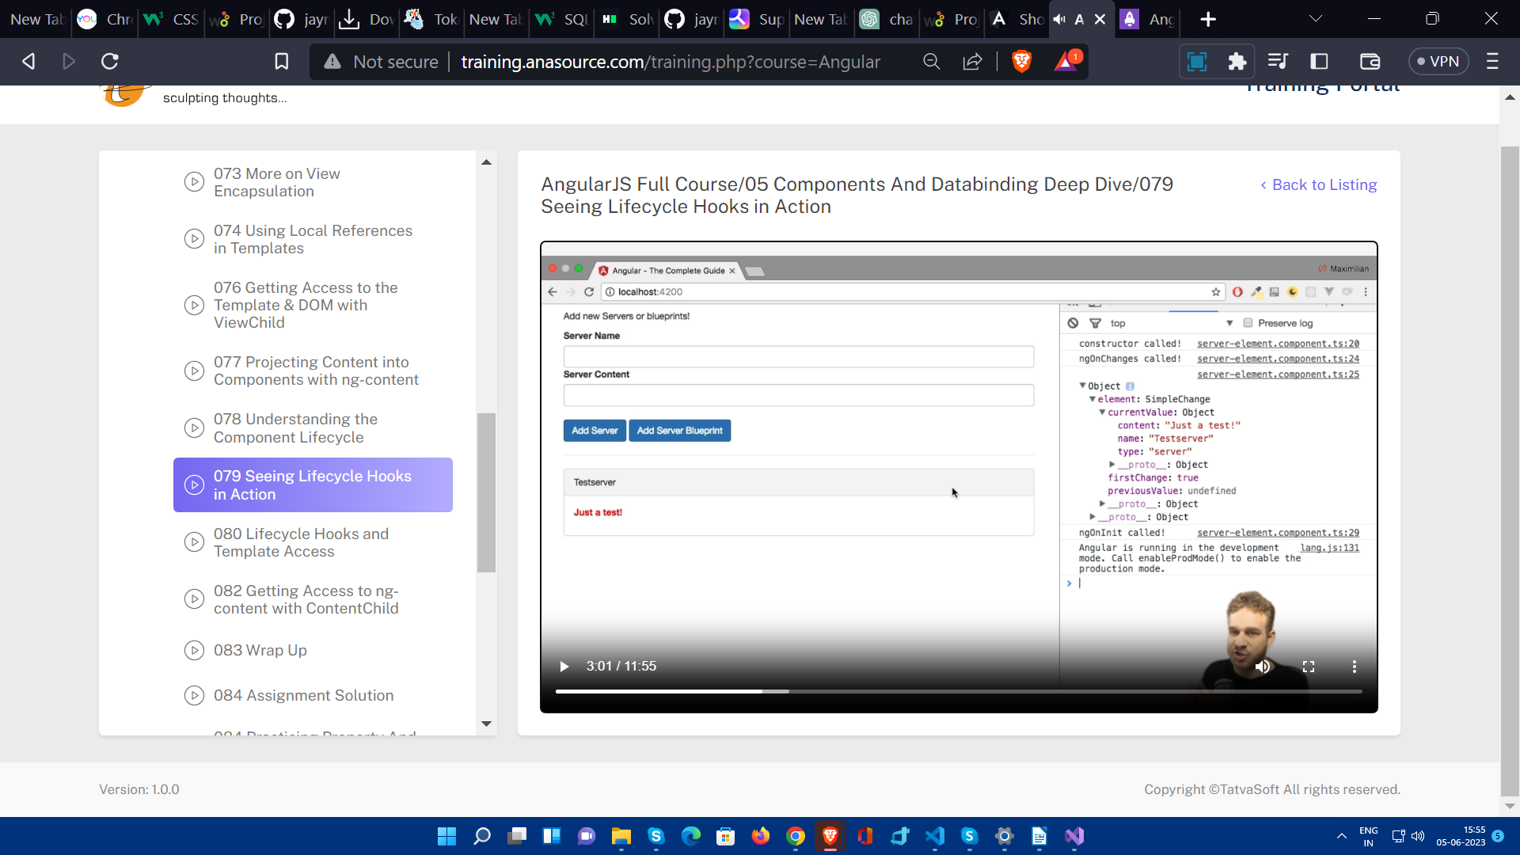

**Directive**

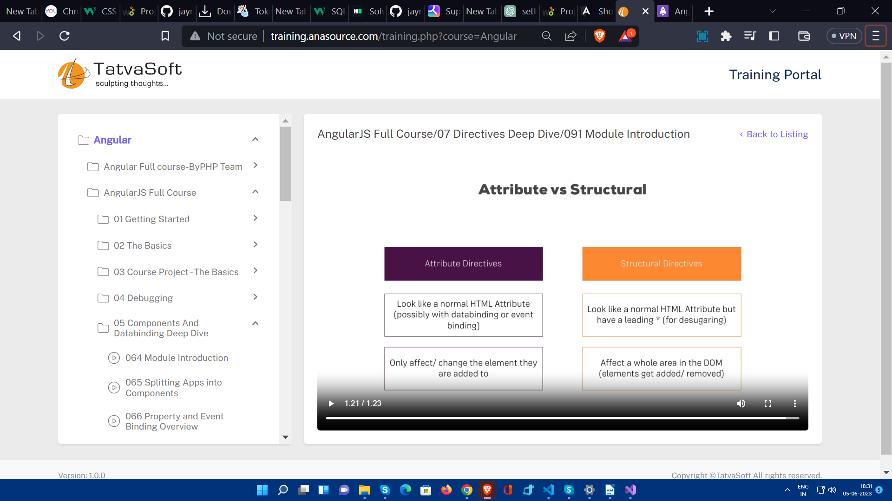

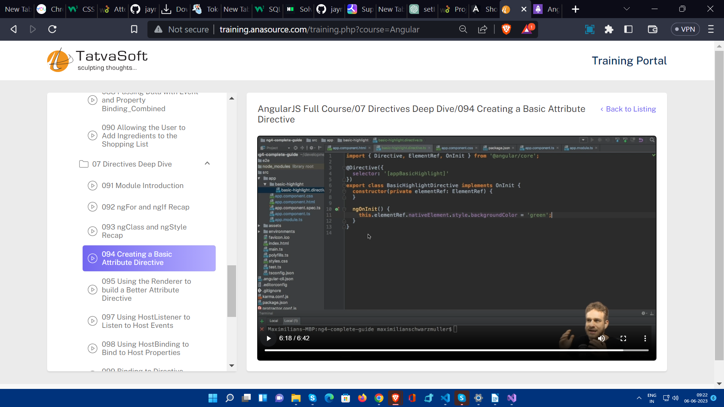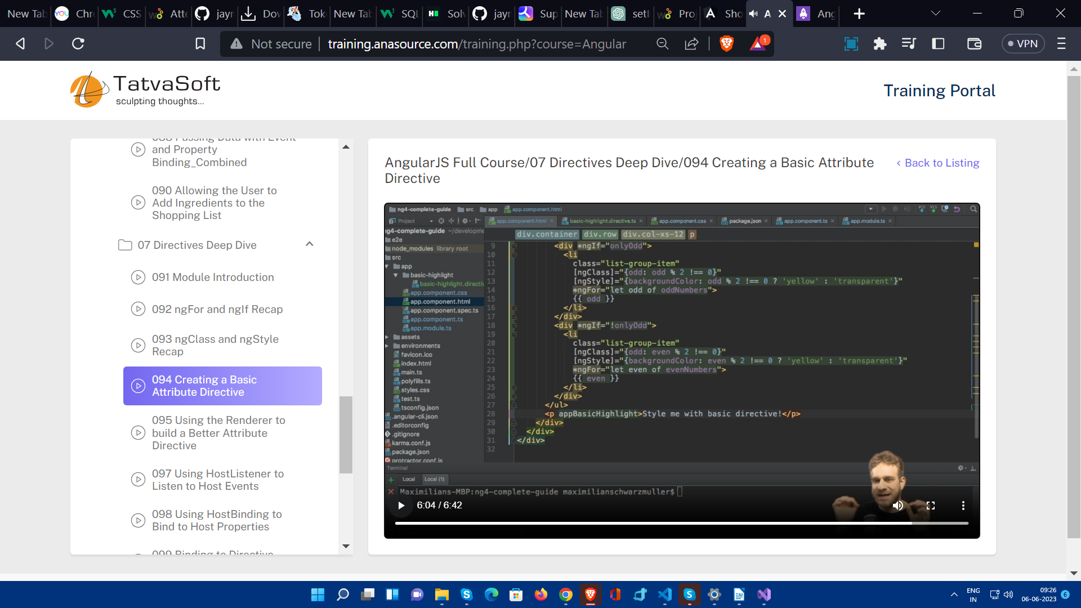

You can make custom directive like this. But still there is one other better approach using renderer.

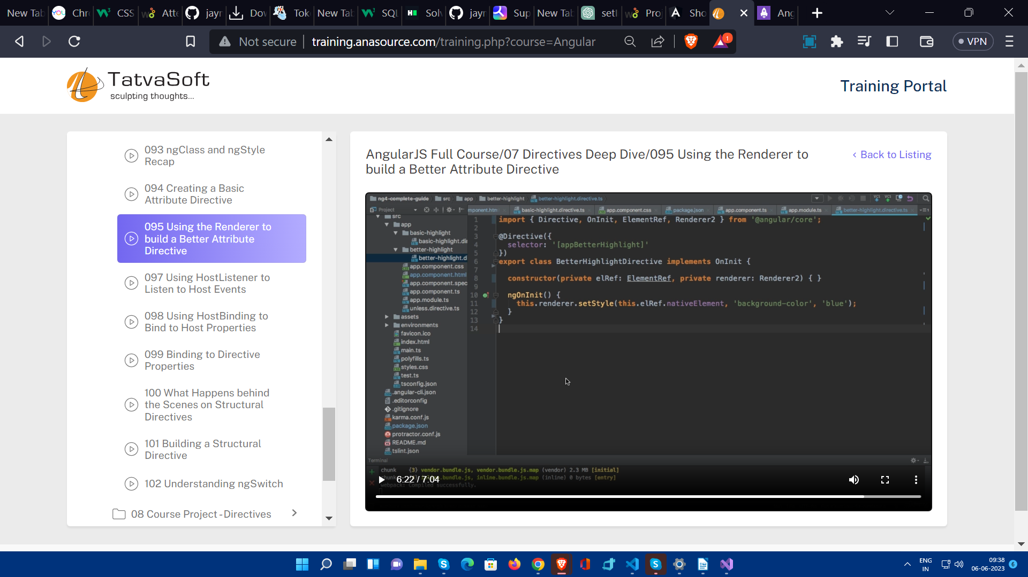

Application of **@HostListener**

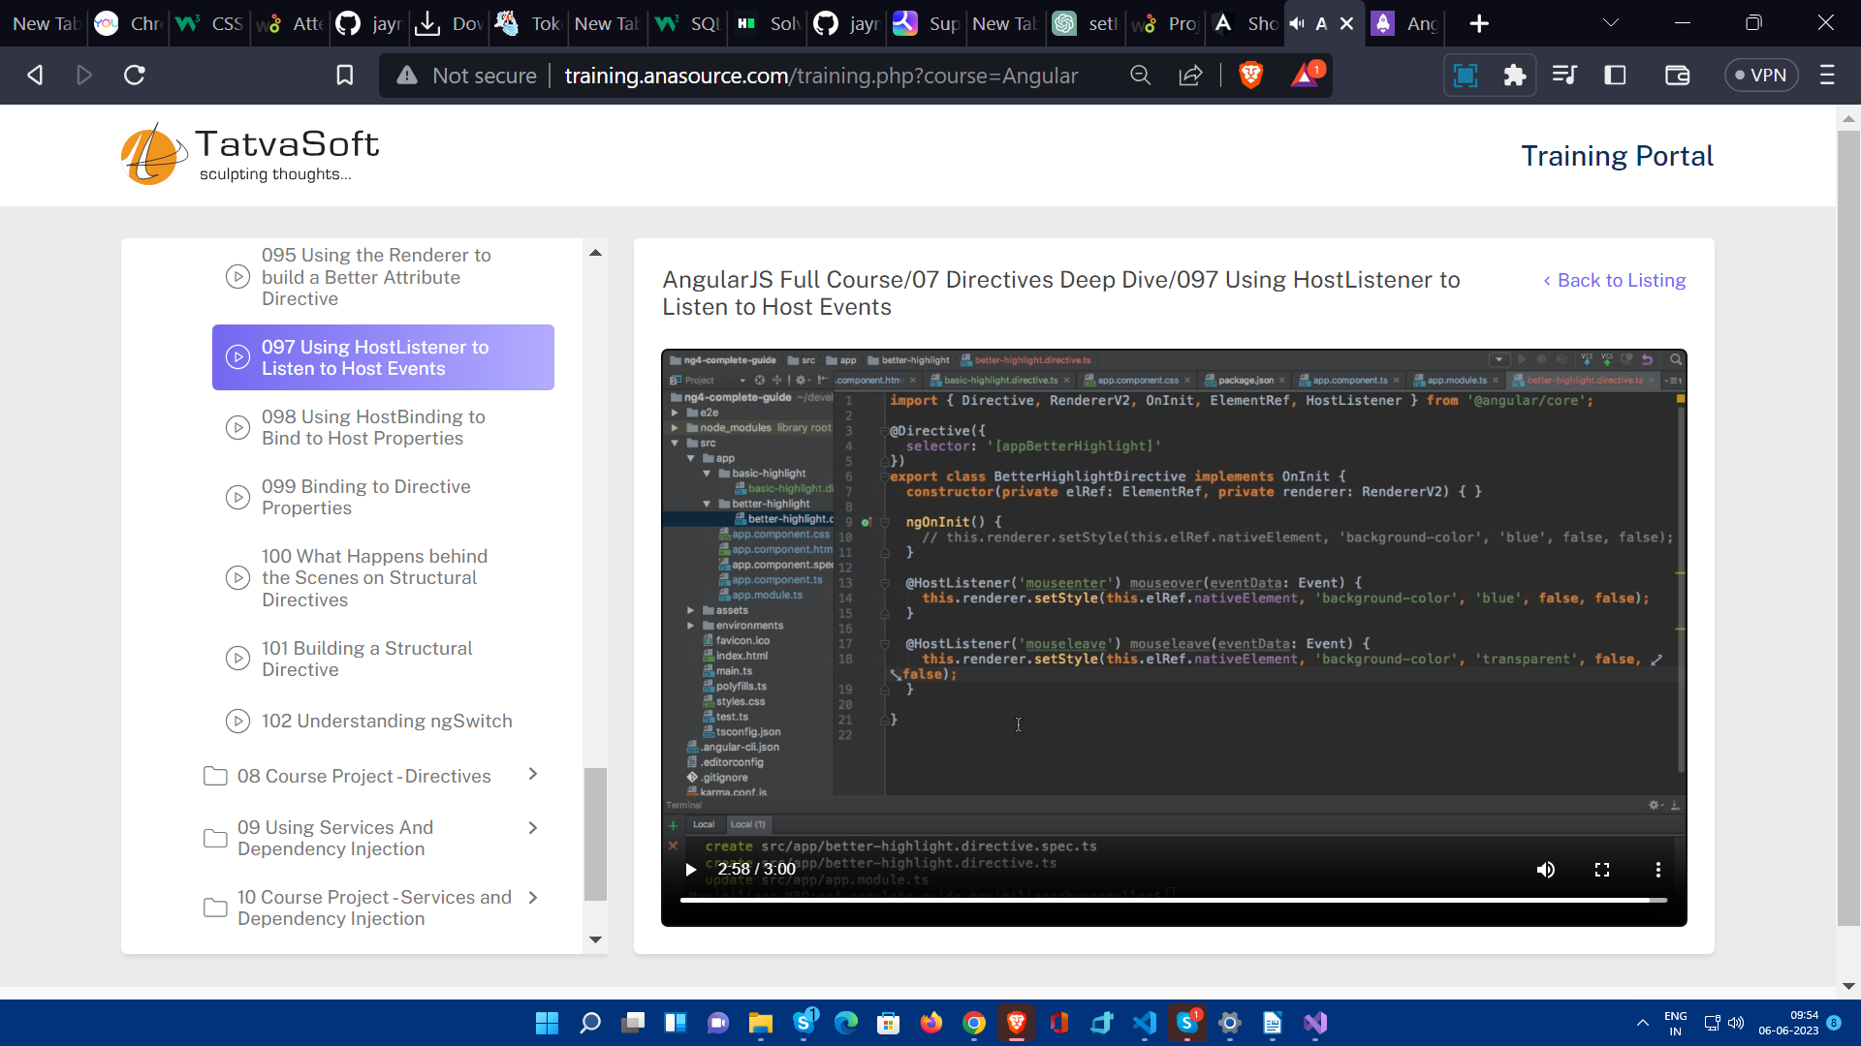

Application of **@HostBinding**

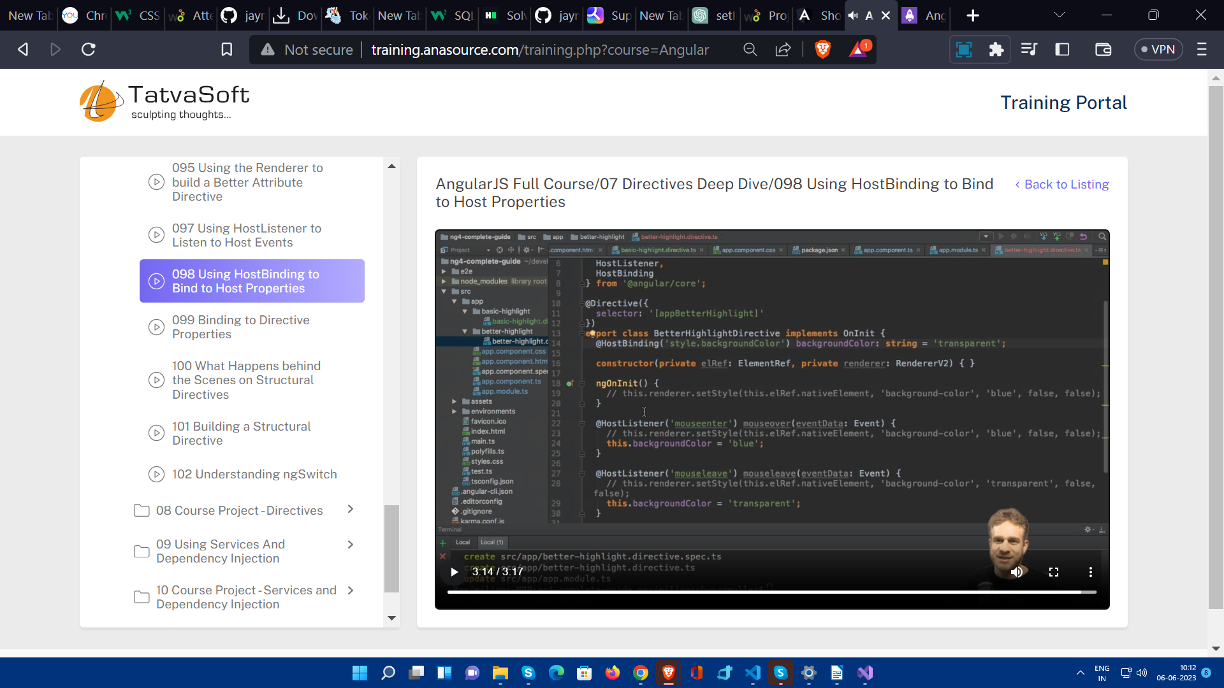

There is still one better way.

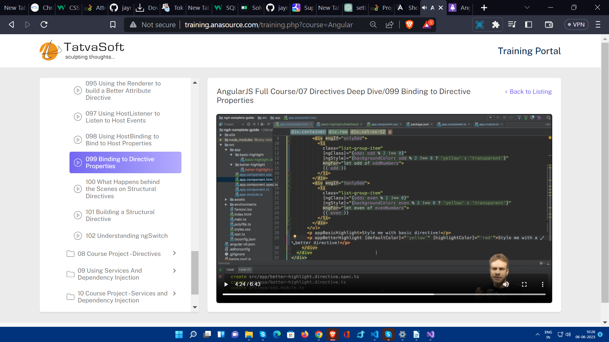

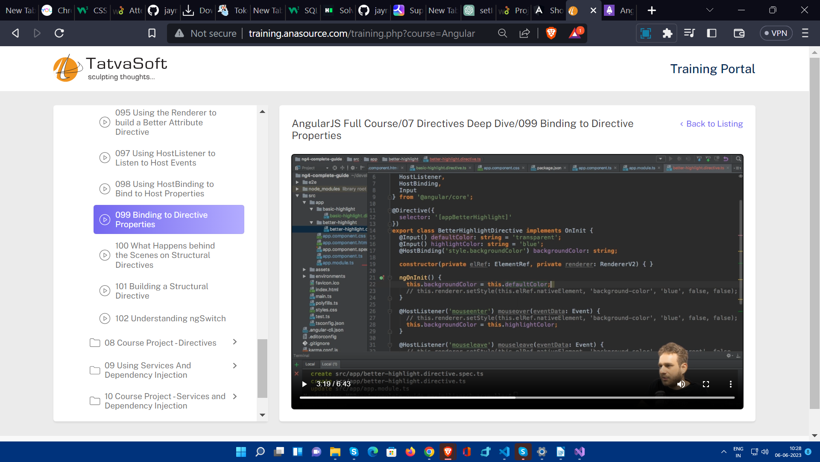

<ng-template>

The <ng-template> directive is a powerful tool in Angular that allows you to create reusable templates, control rendering behaviour, and enhance code organization and maintainability. It provides a way to separate the presentation logic from the component logic and promotes code re-usability.

<ng-template #myTemplate>

<p>This content is rendered when the condition is true.</p>

</ng-template>

<div *ngIf="condition; then myTemplate else elseBlock"></div>

<ng-template #elseBlock>

<p>This content is rendered when the condition is false.</p>

</ng-template>

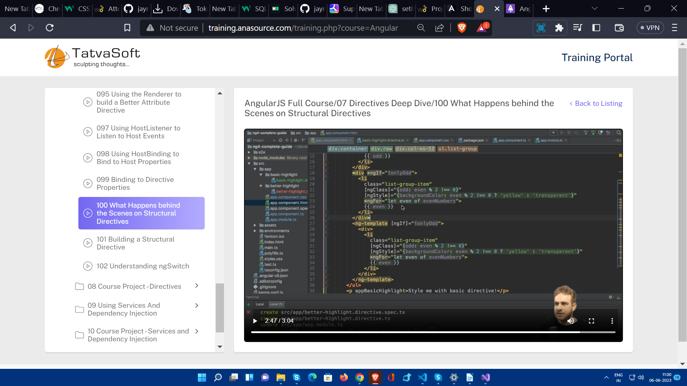

**Custom Structural Directive**

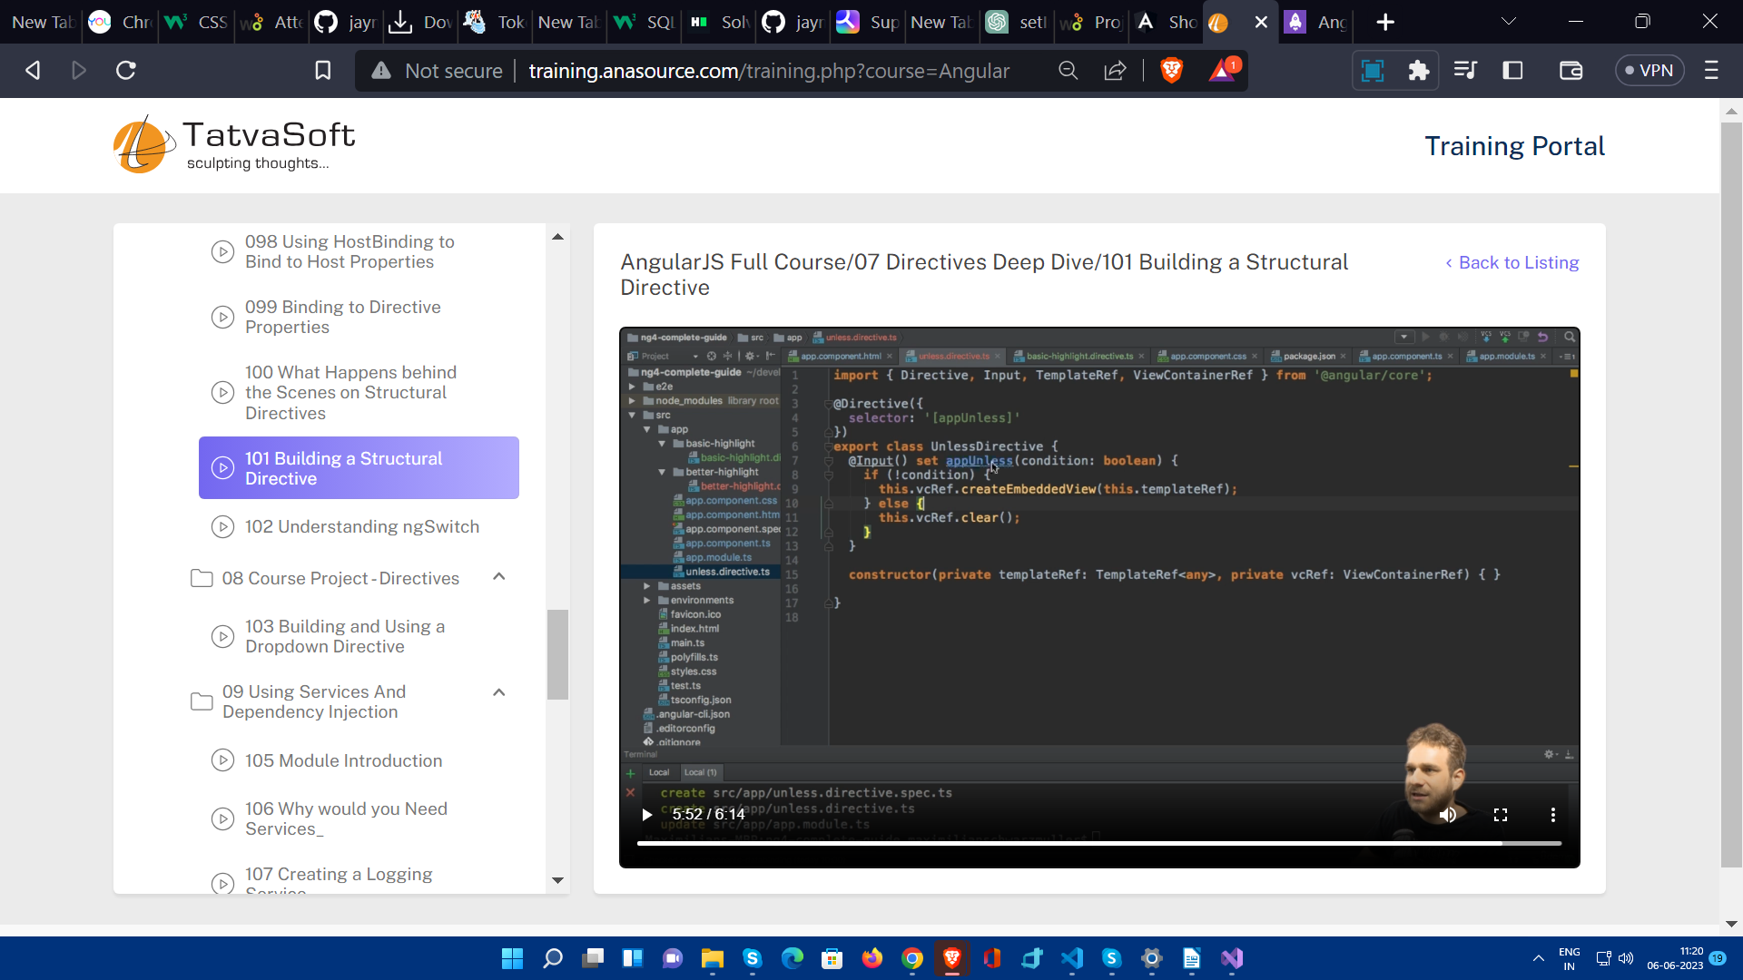

Here it is very notable that selector value “appUnless” and the property which ultimately setter method should be sharing the same name otherwise it will cause error. And then we can use it Like this.

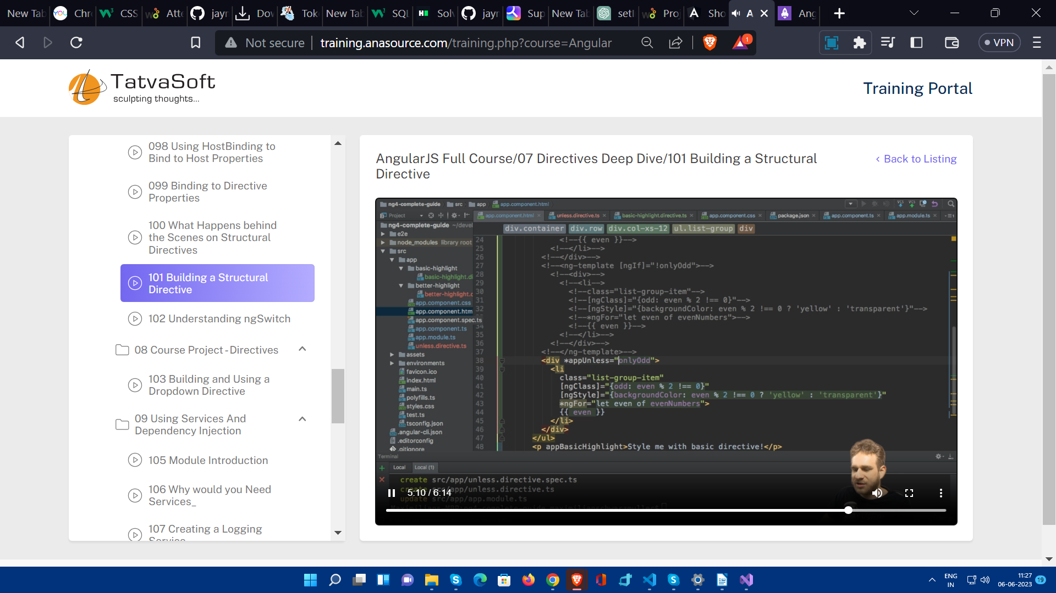

NgSwitch

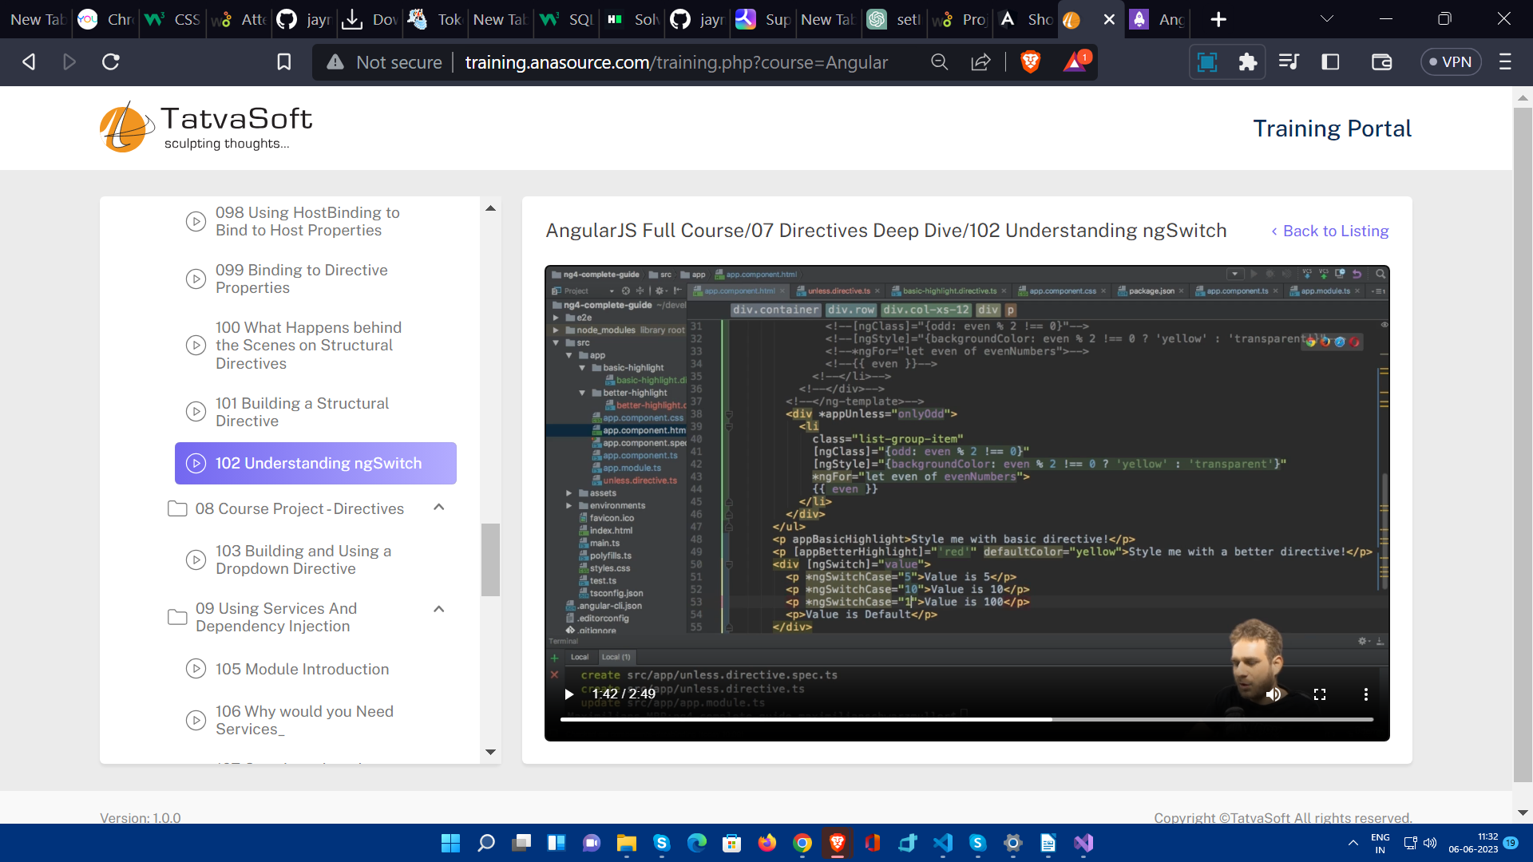

**Services**

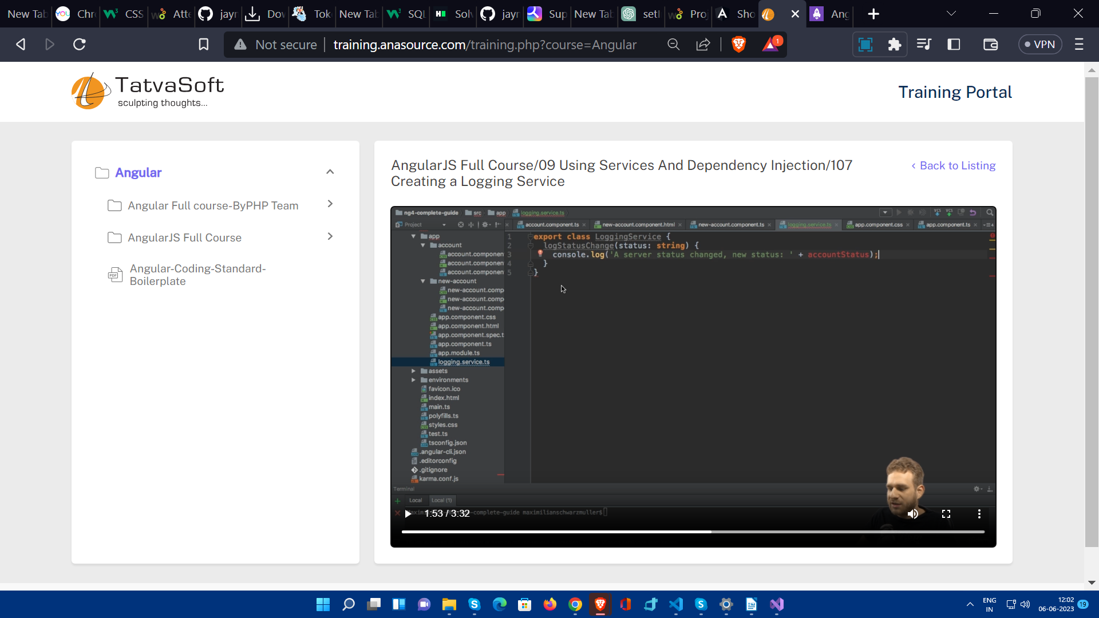

You might be thinking to use services just like a normal way , by creating an instace of that service and calling methods . That will work , but using Dependency Injection is better practice.

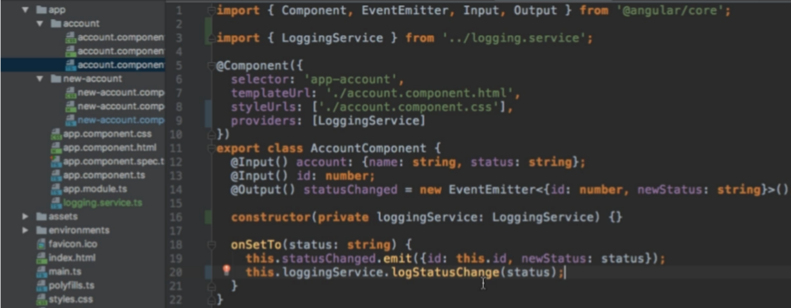

Adding in providers array is very important.

When you inject a service in component , the same instance of that service will be injected to the all of its child components.

If injected in module.ts file application wide same instance.

If injected in app.component.ts then same instance for all the components but not for other services.

So if you want to same instance as of parent component , inject service in constructor , also need to import , but **don’t include service in providers array.**

You can inject a service to other service , for that you have to mention

**@Injectable()**

in the service where you want to inject other service.

**Services for cross component communication**

Suppose in a service we declare

statusUpdated=new EventEmitter<string>();

Then in component used it.

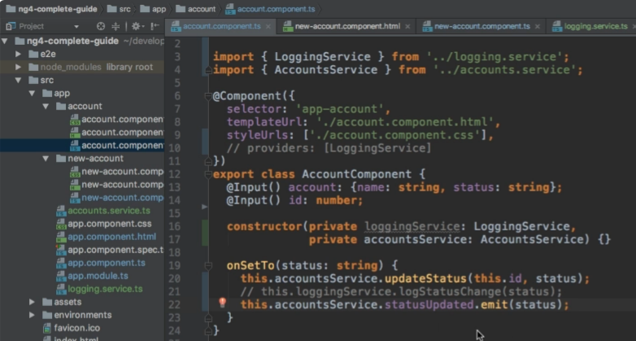

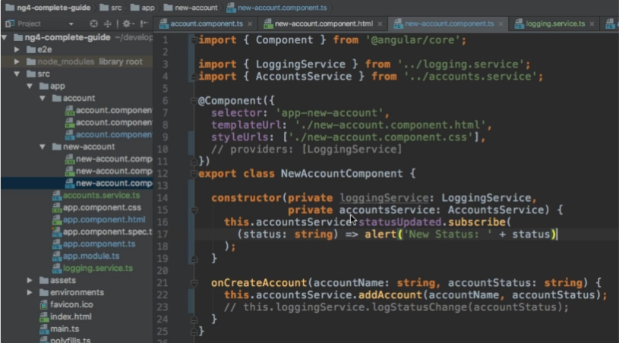

Like this is we can use subcribe() method to wrap the emitted response and use it.

**Routing**

You routerLinkActive to move any class dynamically when gets clicked and routerLinkActiveOptions to avoid default tab always being active.

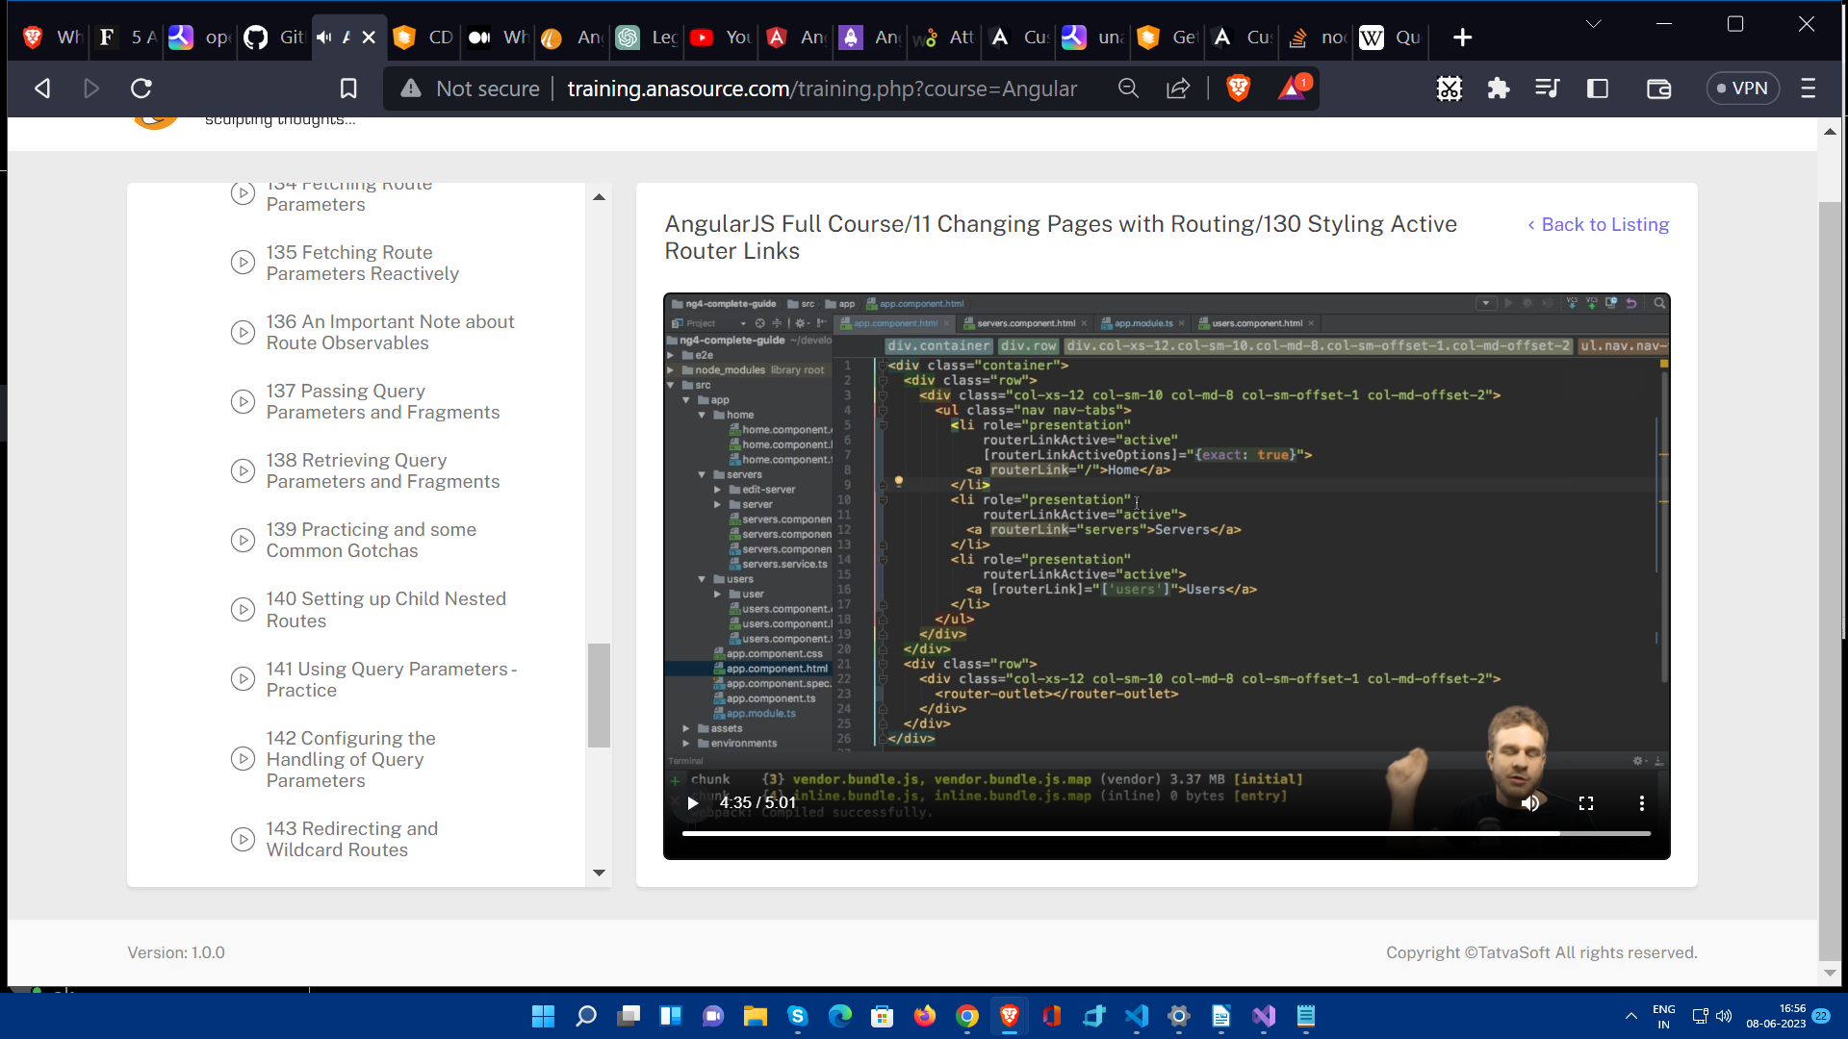

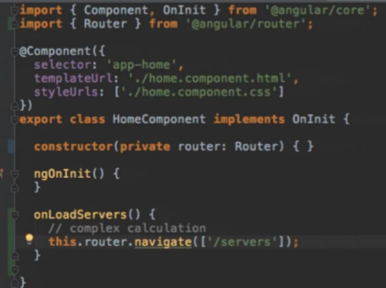Programmatically Routing

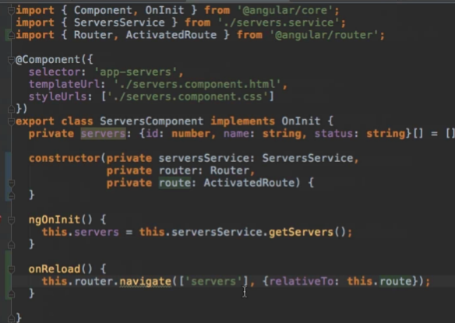

path:’users/:id/:name’ : denotes dynamic part in path.

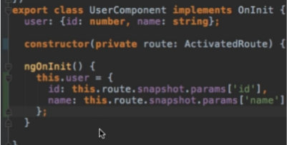

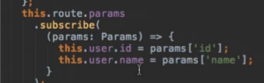

Here params is an observable , if you fill that your param’s values will be changed in future and want to reflect those changes asynchronously then this is very useful.It will get executed whenever parameter will get changed.

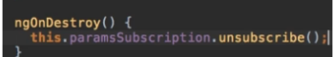

If you make custom observables then you have to unsubcribe onDestroy . Subcription is module of rxjs. And make property of that type.

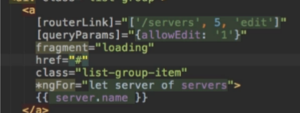

This is how we can send query parameters

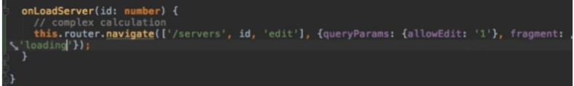

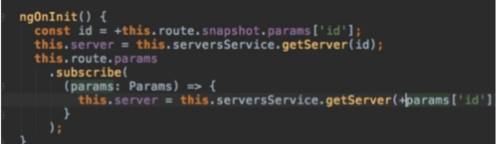

You have to include + before params and this.route. .... so that it automatically converts ‘1’ to direct int 1.